ANCOVA

**Description:**

ANCOVA is a type of analysis of variance that allows you to first control for variable(s) that change the relationship of the independent variable with the dependent variable.

**Definitions/Abbreviations:**

CV – covariate. This variable changes with the dependent variables and is used to adjust the dependent variable to create equal groups or eliminate nuisance information. CVs can be either a continuous variable (such as age) or a categorical variable (such as gender). CVs are used to adjust the values of the dependent variables, usually to create larger group differences on your independent variables.

IV – independent variable. This variable *has* to be a categorical variable. You can put people into groups based on any category (gender, handedness) or your experimental manipulation (instructions versus no instructions).

DV – dependent variable. The dependent variable *needs* to be a continuous variable or another type of analysis might work better (see log regression). Your dependent variable should be the measurement you took in your study or what information you are expecting to see changed over groups.

**Power:**

You want to check how many people you need to run (or alternatively, how many more people you need in a study).

Using G*Power, finding ideal participant numbers is fairly easy. Set up options:

* Test family: F-tests
* Statistical Test: ANCOVA: Fixed effects, main effects, and interactions.
* Type of power analysis: A priori (most common)
* Effect size f: either guess at an effect size based on research, use a small effect size for good measure, or after a couple subjects run a prelim ANCOVA and use the current effect size. (You can click determine to convert eta squared to f).
* Alpha = .05
* Power = .80
* Numerator df = Levels – 1 or (levels-1)*(levels-1)
* Number of groups = number of conditions
* Number of covariates = number of CVs.

Hit calculate for the number of participants needed.

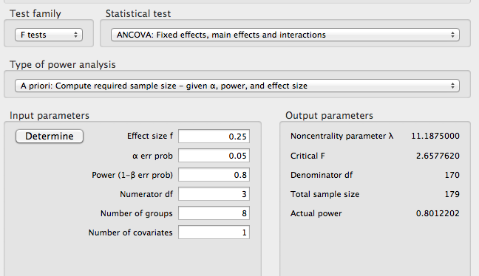

**Assumptions:**

Missing Data and Accuracy: You perform checks for missing data and accuracy just like in the data screening chapter.

Outliers:

* Univariate – outliers only on the CV or the DV. You want to check z-scores for people who are more than 3 (3 or -3) away from the mean.
* Multivariate – outliers on the CV and DV combination. This procedure uses Mahalanobis distance to make sure that people do not have a strange combination of answers on the CV and DV.
  + You can do both of these or just Mahalanobis. You may not want to eliminate people who are a univariate outlier on one variable, but you really should eliminate people who are multivariate outlier.

Multicollinearity: You want to check your CVs (if more than one) by using a correlation to make sure they do not overlap too much. If they overlap a great deal, then you want to use only one of them or combine them. Look for variables with *r* > .70.

Linearity: Linearity between the CV and DV is a very important issue. If you are using a regression to adjust the values of the DV with the CV, then there needs to be a linear relationship. You can check for this value using a fake regression or bivariate scatterplot.

Normality:

* Univariate – you want the CV and the DV to be normally distributed by themselves. You can check this information through frequencies and asking for a histogram. Non-normal distributions also have skew and kurtosis values over 3/-3.
* Multivariate – you also want the CV and DV combination to be normally distributed. You can check for multivariate normality by running a fake regression and asking for a histogram of the residuals.

Homogeneity: the variance of the groups from your IV need to be equal across both the DV and CV. You can check this information with a residual plot from your fake regression (you do not want raining or an unequal spread of the dots around 0). You can also use Levene’s test of homogeneity – you *do not* want p < .001.

Homoscedasticity: the spread of the scores on the CV need to be equal around all the values of the DV. You have to check this assumption by looking at a residual plot from a fake regression. You do not want a megaphone shape.

# Complete Example – All Between

The researcher has measured participant’s attitudes toward the use of drugs to see if there are group differences in attitudes. They also measured physical health symptoms to control for people who report more symptoms will have more positive attitudes towards drugs (because they are sicker). Finally, they grouped people by employment status and religion to analyze group differences and interactions on attitudes.

**IVs:**

Employment – employed versus unemployed.

Religion – none, Jewish, Protestant, Catholic.  
**CV:**

Phyheal – physical health, higher scores indicate more health symptoms (problems).

**DV:**

Attdrug – attitudes towards drugs, higher scores indicate more positive attitudes.

**Assumptions Checks:**

Univariate outliers:

1. Analyze > Descriptive Statistics > Descriptives

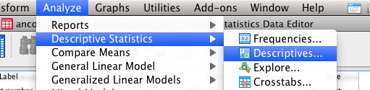

1. Move over the CV and DV into the descriptives box.
2. Hit save standardized values as variables.

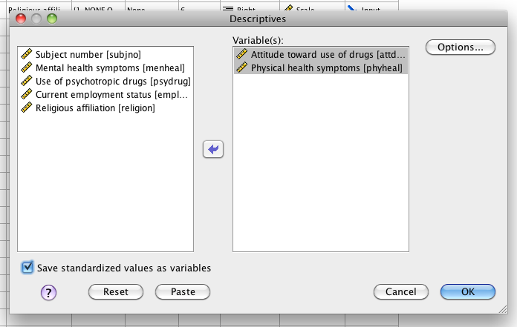

1. Hit options > skew and kurtosis.

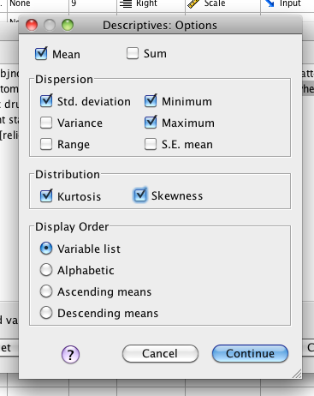

1. Look for univariate outliers.
2. Go back to the data set. You should see two new variables for z-scores of the CV and DV.

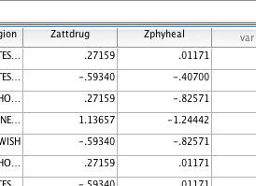

1. Sort those variables one at a time – look for values over 3 and -3 (right click sort).

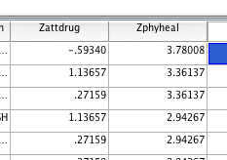

1. Here I see several univariate outliers for physical health symptoms. I am going to check for multivariate outliers before I eliminate them though.

Multivariate outliers:

1. Create a fake variable to use for your fake regression.
2. Transform > compute variable.

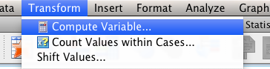

1. Call the target variable “random”. Use one of the random functions to create your random variable.

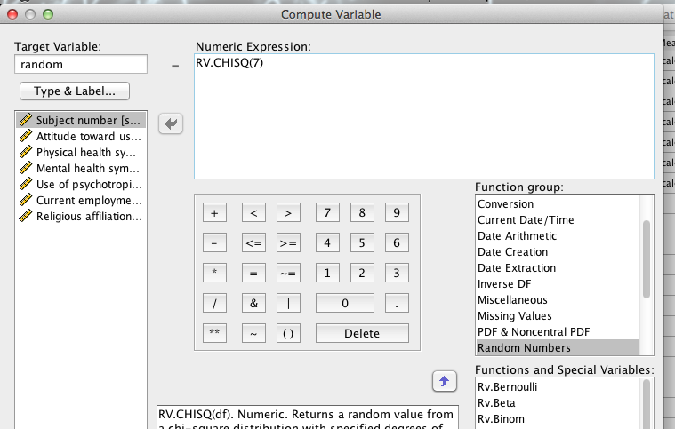

1. Hit “ok”, and it will create a new random variable for you.
2. Run a fake regression. Analyze > Regression > Linear.

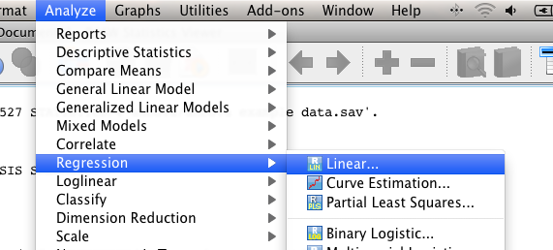

1. Move your random variable into the DV box. Put your **CV and DV** into the independent(s) box.

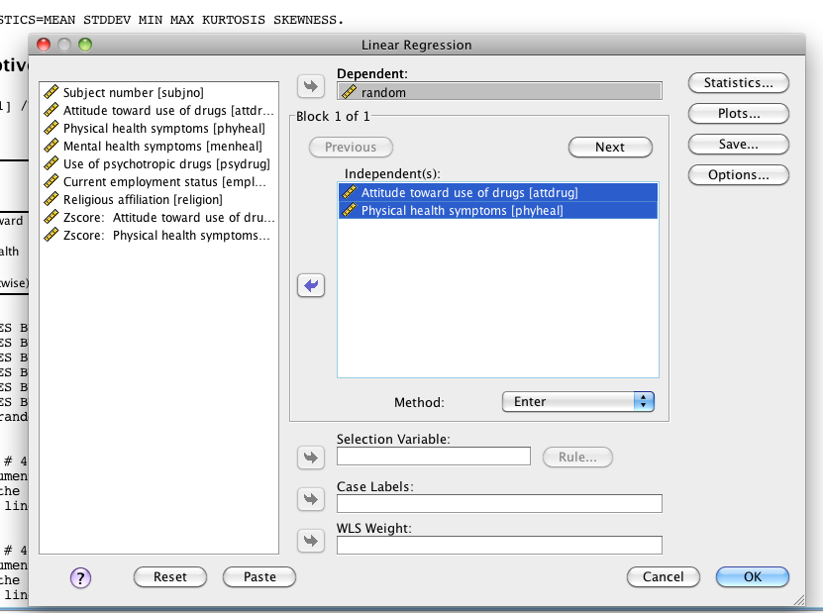

1. Hit Plots.

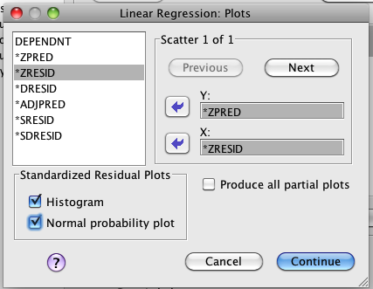

1. Put zpred in Y and zresid in X. This section will create the residual plots for other assumptions checks. Check histogram and normal probability plot.
2. Hit Save.

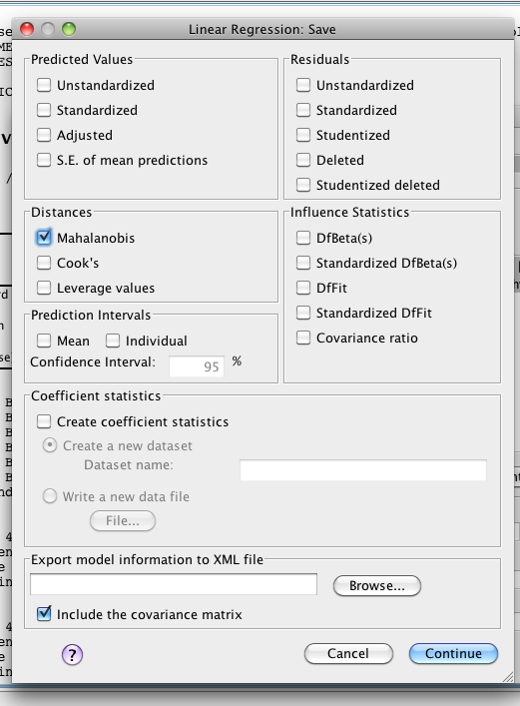

1. Check Mahalanobis – it will create another new variable for you to check.
2. Go back to the data set, and sort cases descending for Mahalanobis.
   1. You will need a cut off value to understand these scores.
   2. The cut off value is chi-square with degrees of freedom = number of variables, p<.001.
   3. Here we have two variables (CV and DV), p<.001, chi square = 13.82 cut off score.
   4. You will look for people who have a Mahalanobis score greater than > 13.82.

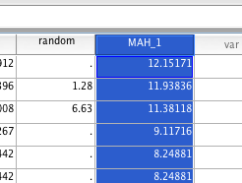

1. We do not have multivariate outliers. I am not going to exclude the univariate outlier because they were not a multivariate outlier.

Multicollinearity – this assumption is not an issue because we do not have more than one CV. If you had more than one CV you would do the following:

1. Analyze > correlate > bivariate.

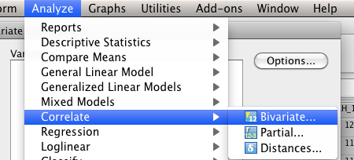

1. Move all your CVs to the right hand side and hit ok.

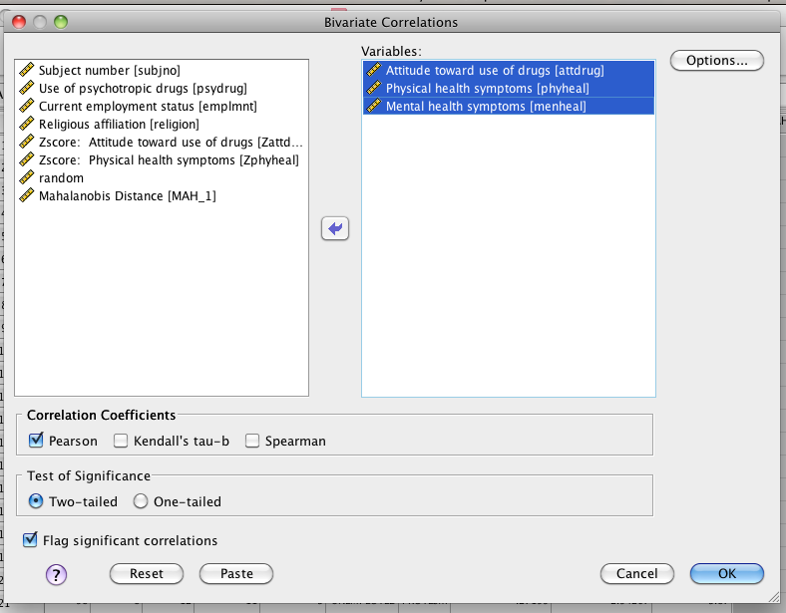

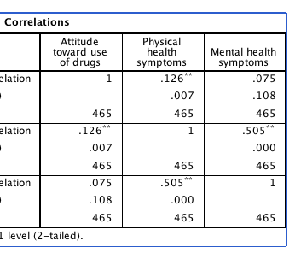

1. You want to make sure no correlations are over r = .7.
2. None of these are greater than .7, so we would be ok.

Linearity:

1. You can check linearity with the fake regression you’ve already run.
   1. IF YOU DELETED OUTLIERS: run the regression again, just as it describes above.
   2. IF YOU DID NOT DELETE OUTLIERS: you can use the output you already have.
2. Scroll down to the Normality Probability Plot.

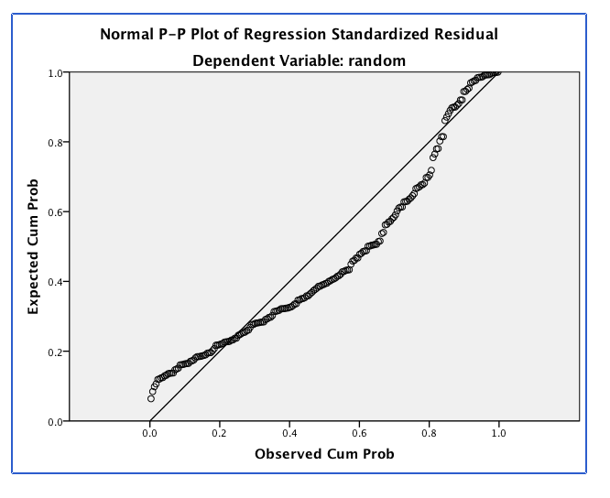

1. You want the dots to follow along the line moderately closely. This picture is looking bad.

Normality:

1. Univariate normality:
   1. You will need to get individual histograms of your CV and DV.
   2. Analyze > Descriptive Statistics > Frequencies.

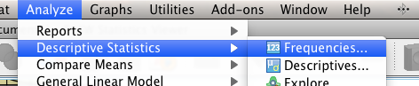

* 1. Move over the CV and DV into the right hand box. I turned off frequency tables because I didn’t want them.

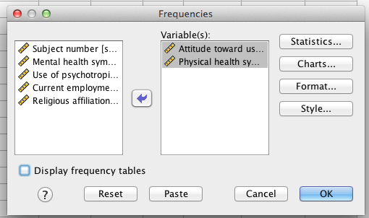

* 1. Hit charts. Pick Histogram and Normal Curve.

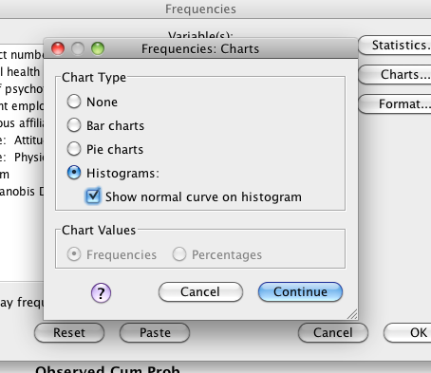

* 1. Hit continue and Ok.
  2. Now you’ll want to check the charts to make sure they look ok.

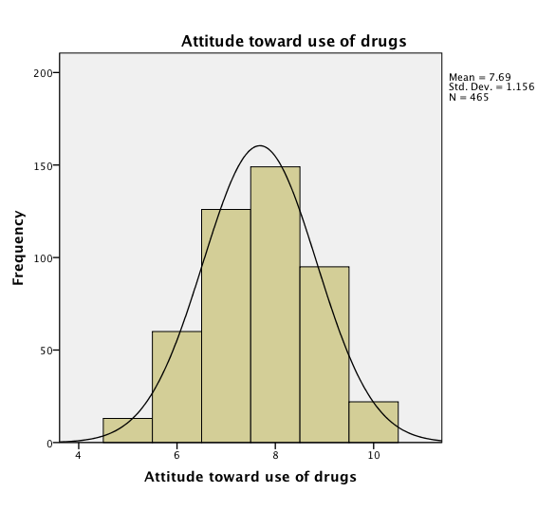 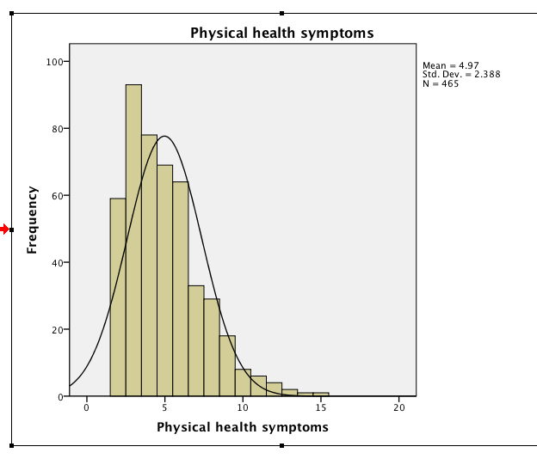

* 1. Both of these look ok, but maybe Physical Health is a little not-normal. I can go back and check skew and kurtosis if I’m not sure. (See the top when you ran descriptives).
  2. Both of these are under 3, or -3, so I’m good.

1. 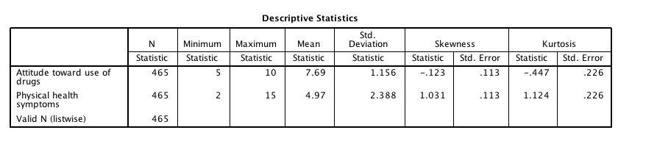Multivariate Normality: use the histogram created from your fake regression to check the CV and DV combination.

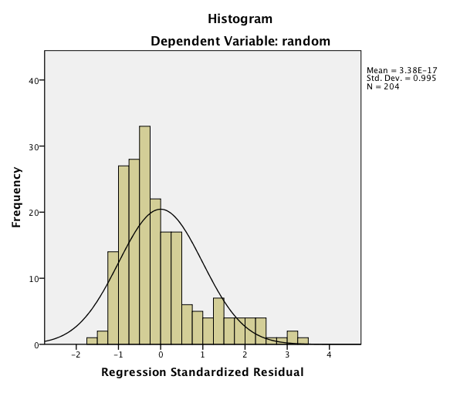

* 1. This histogram looks fairly normal, starting to be slightly skewed.

Homogeneity and Homoscedasticity: you can check these assumptions using the residual plot from the fake regression you ran earlier.

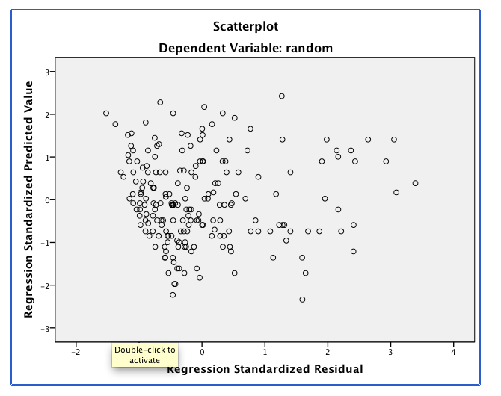

1. What to look for:
   1. Draw a line at 0.
   2. Homogeneity – is the spread above that line the same as below that line?
      1. These lines are complete lines.
      2. So it goes from 0 to 3 above and 0 to -3 below.
      3. You *do not* want a very large spread on one side and a small spread on the other side.
      4. If you encounter this problem – check Levene’s when you run the data.
   3. Homoscedasticity – is the spread equal all the way across the zero line?
      1. These lines are the dashed lines.
      2. Do the dashed lines create a megaphone shape? No, but the bottom is missing some scores.

**Running the ANCOVA:**

1. Analyze > General Linear Model > Univariate (because we only have between subjects variables).

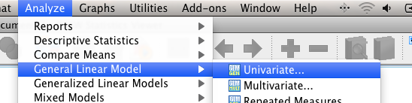

1. Dependent variable goes into the dependents box, IVs go in the fixed factor box, CVs go in the covariate box.
   1. Aren’t sure? Go back and figure out what type of variables they are (dichotomous, continuous) and see what type that makes them.

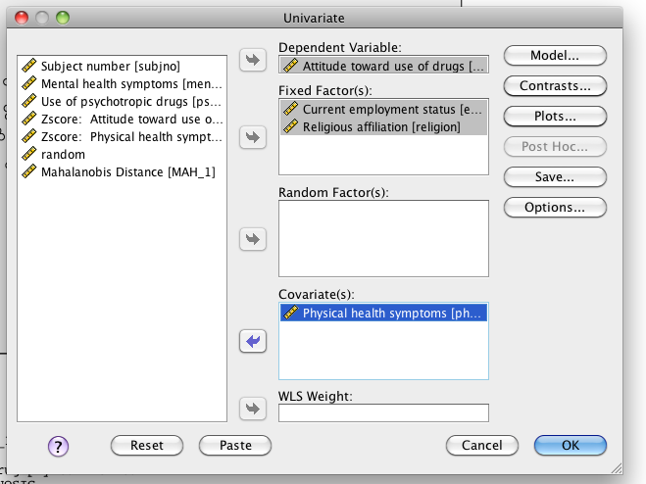

1. Hit options > move over the variables for descriptive statistics. Pick options descriptives, estimates of effect size, and homogeneity (this is Levene’s test).
   1. Also you will select compare main effects. This option will give you post hoc tests for the *main effects* only but on the adjusted marginal means. Remember that the post hocs will run no matter what – so if you only have two levels (like we do for employment in this example), you will want to ignore that output.

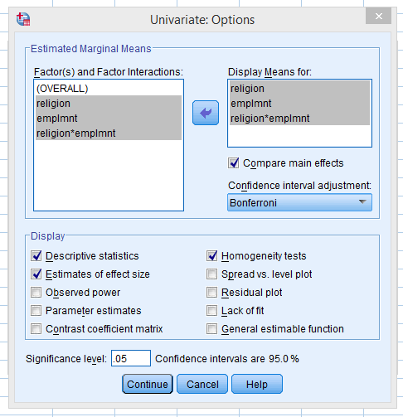

1. Click plots.
   1. Move one over to horizontal access, one to separate lines, hit add.
   2. Do the reverse! So you don’t have to ask for plots multiple times.

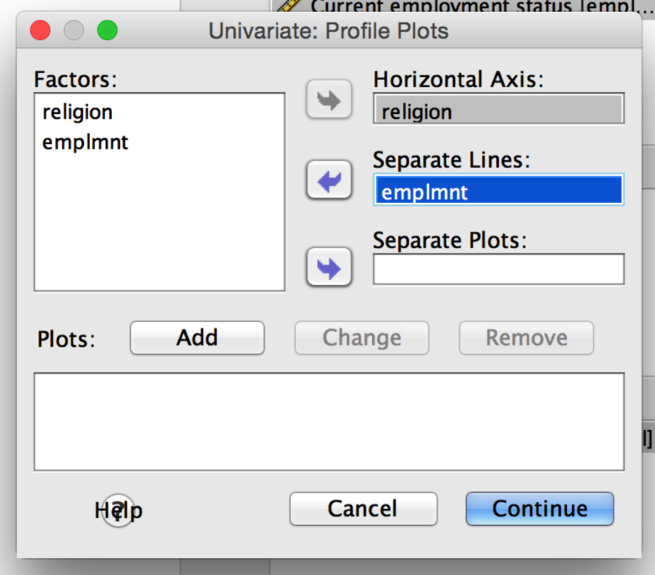

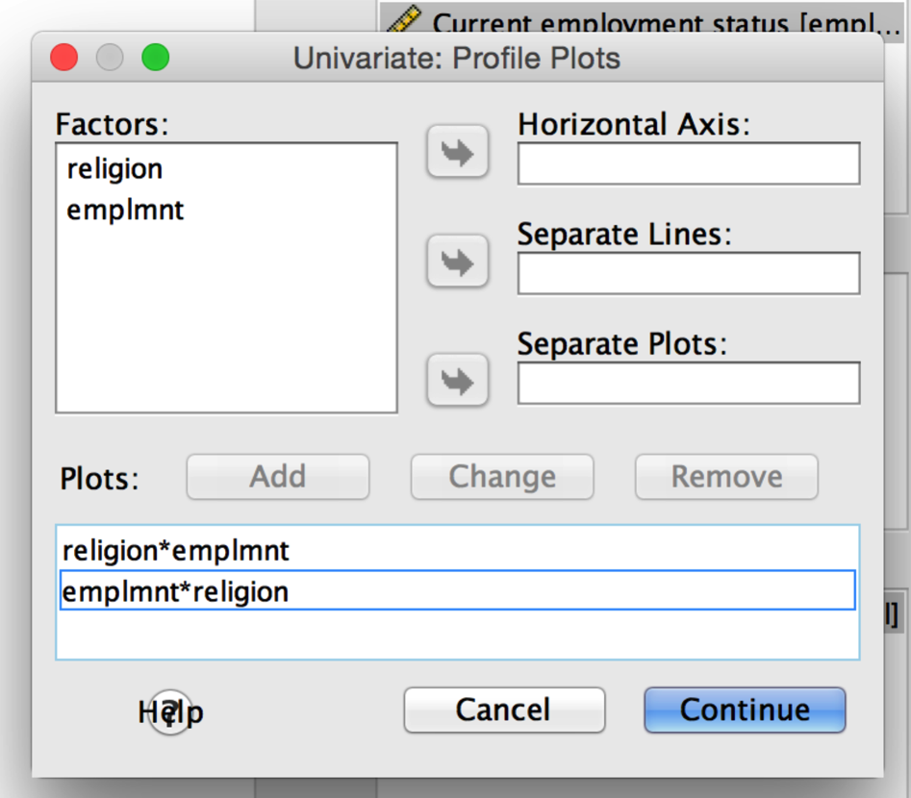

1. Hit continue and ok (you cannot get interaction post hocs with ANCOVA).

**Going from Output to Results Section:**

1. Check Levene’s for Homogeneity – especially if your residual plot was not evenly distributed. You want p > .001.

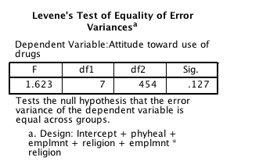

* 1. Levene’s is p = .127 so we are ok.

1. Covariate Significance: You get this information from the Between Subjects ANOVA box. You are looking for p < .05.
   1. Our CV – physical health is significant at p < .05.
   2. Write up – *F*(1, 453) = 6.65, *p* = .01, *np2* = .01

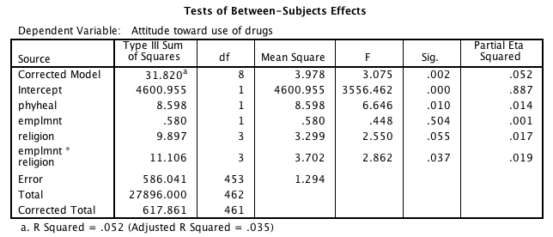

Degrees of Freedom for tests.

* the first number or top box is the first number in the f-statistic.
* The error line or second box is the second number in the f-statistic.

F-values – used to write after the equal signs.

P-values, check these for p<.05

Effect sizes – to be listed with f-statistic.

1. What it means if your covariate is significant?
   1. It means that your CV is a significant adjustor of the DV.
   2. I would run a correlation to figure out how it’s adjusting.
   3. See above (multicollinearity) on how to run a bivariate correlation.
   4. It appears there’s a positive relationship between attitude toward drugs and physical health symptoms.
2. Main effect of employment.

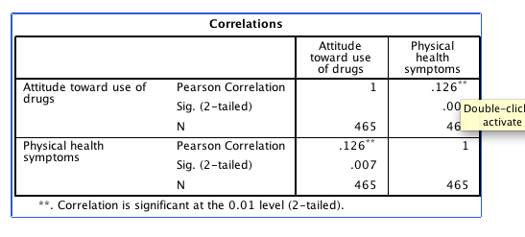

* 1. Look at the ANOVA box listed above. Since *p* =.50, there is not a significant effect of employment.
  2. Write up: *F*(1, 453) = .45, *p* = .50, *np2* < .001.
  3. Means:

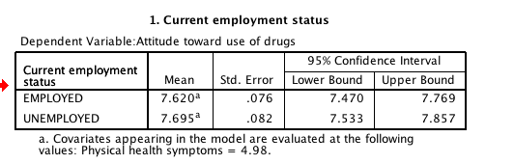

* 1. You will get the following post hoc box because you selected Bonferroni in the options window. Because we only have two levels, you will want to ignore this information (both boxes).

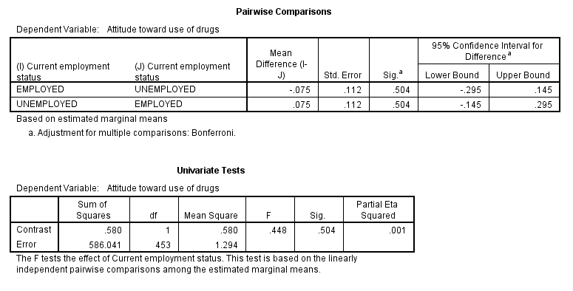

1. Main effect of religion.
   1. Look at the ANOVA box listed above. Religion is close to being significant at *p* =.055. You can usually get away with running post hoc tests for the main effect here, but since there is an interaction we’ll just save them for the interaction.
   2. Write up: – *F*(3, 453) = 2.55, *p* = .06, *np2* = .02.
   3. Means:

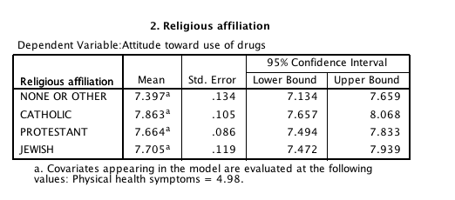

* 1. If you wanted to do the post hoc for the main effect here, you could use the following output (that occurs underneath the estimated marginal means).

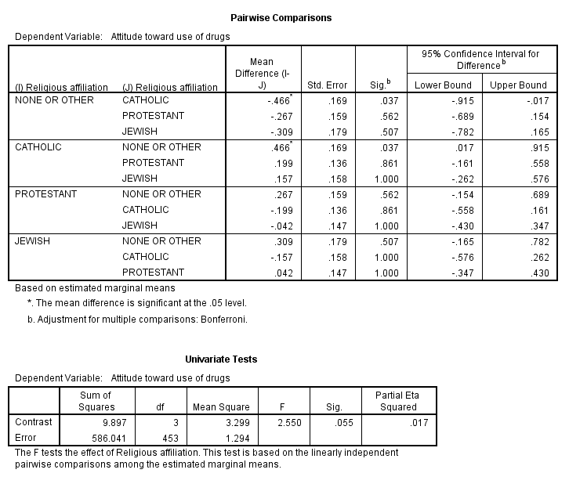

* 1. You would be comparing each level to every other level, as described in the ANOVA section. These are independent t-tests with a Bonferroni Type 1 Error correction. In this example, only None or Other is different from Catholic (the attitudes towards drugs for none are lower than the attitudes for Catholics).

1. Employment by religion interaction.
   1. Look at the ANOVA box listed above. Since *p* < .05, there is a significant interaction between employment and religion’s attitude towards’ drugs after controlling for physical health.
   2. Write up – *F*(3, 453) = 2.86, *p* = .04, *np2* = .02.
   3. You will want to run a post hoc analysis to figure out what that interaction means.
   4. Means:

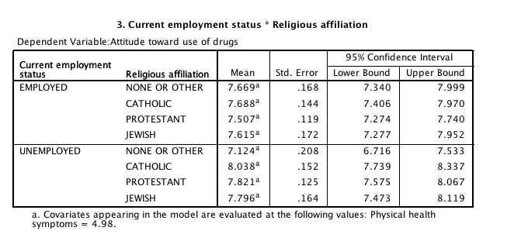

1. Post Hocs.
   1. First, I find it easiest to recreate a table to look at my interaction.

|  |  |  |  |  |
| --- | --- | --- | --- | --- |
|  | None | Catholic | Protestant | Jewish |
| Employed | M=7.67, SE=.17 | M=7.68, SE=.14 | M=7.51, SE=.12 | M=7.62, SE=.17 |
| Unemployed | M=7.12, SE=.21 | M=8.04, SE=.15 | M=7.82, SE=.13 | M=7.80, SE=.16 |

* 1. You would need to pick a direction to analyze the interaction. Do you want to compare across – employed none versus employed catholic? Or do you want to compare down – employed none versus unemployed none? Only do *one* direction. You can use the plots to figure out which one makes more sense to you.

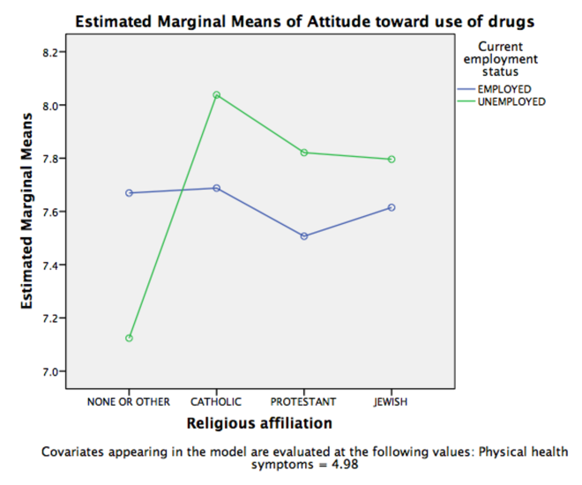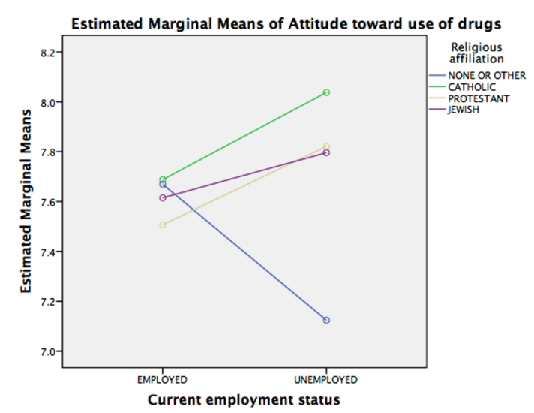

* 1. Be sure you are using the **estimated marginal means!!**
  2. I’m going to compare going down because that creates less tests than comparing across.
     1. Down = 4 (employed v unemployed for each religion)
     2. Across = 12 (employed: each religion to each other; unemployed: each religion to each other).
  3. There are several options for the post hoc described below.

Running a post hoc:

Option 1: Use SPSS individual group ANCOVA.

For this option, we are going to use ANCOVA but limit our comparisons to two-conditions at the same time. Remember that with pairwise comparisons (aka two at a time) ANOVA = independent t. We cannot use regular independent t-tests run through SPSS because want to use the adjusted means and control for the CV(s). This analysis will allow us to control for the CV(s), and compare pairwise without leaving SPSS. However, option 2 and 3 would be better for using the exact means from the conditional means box shown above. This analysis will give you slightly different means.

Here are the post-hocs I’m calculating:

|  |  |  |  |  |
| --- | --- | --- | --- | --- |
| Mean 1 | Mean 2 | F(df,df), p | η2 | Explain |
| None  Employed | None  Unemployed |  |  |  |
| Catholic  Employed | Catholic  Unemployed |  |  |  |
| Protestant  Employed | Protestant  Unemployed |  |  |  |
| Jewish  Employed | Jewish  Unemployed |  |  |  |

*Note*. I’ve got eta in this table because we are using F-tests to analysis the post hoc. You could also calculate Cohen’s *d* on the adjusted means, which would also be correct.

1. First, split the dataset (this type of analysis will work for all between subjects).
   1. Data > Split file

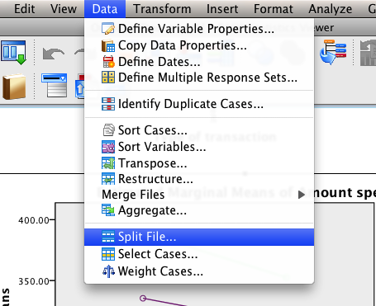

* 1. Pick the variable you want to “split” on.
  2. Split on the larger variable – the one with more levels (unless you have a specific hypothesis).

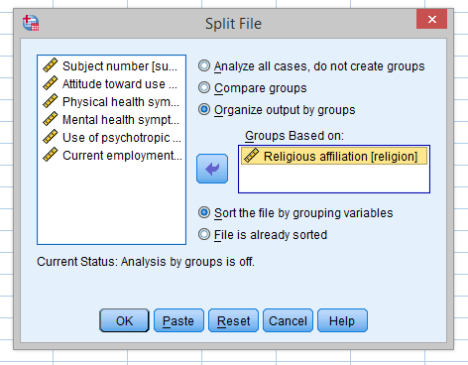

1. Now the file is set up for me to run individual ANCOVAs on employed versus unemployed, separated by each type of religion.
2. Analyze > General Linear Model > Univariate



1. Dependent variable goes into the dependents box, the non-split IV goes in the independent box, CV goes in the covariate box.

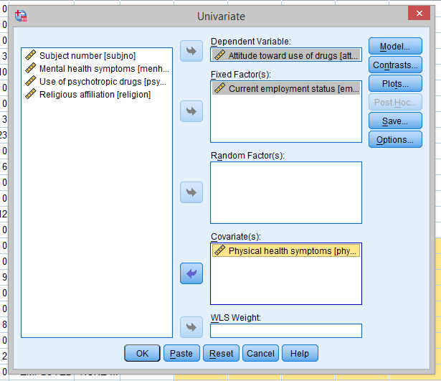

* 1. Click options.
     1. Move over the one IV to get the adjusted marginal means.
     2. Click compare main effects.
        1. Why? We only have two levels (employed versus unemployed).
        2. Well, in case you have three or more levels, you can get all the comparisons pairwise (which is much faster than using select cases).
        3. Here, I’ll just get extra output to ignore.
     3. Descriptives to get the marginal means, effect size to get eta squared, homogeneity because I always click it (Levene’s has already been checked).
  2. Click continue and ok.

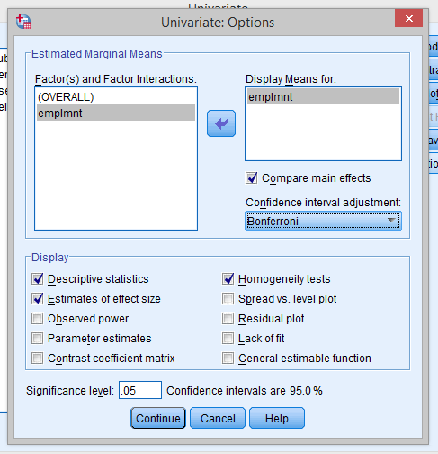

1. Interpret the output.
   1. Anytime you get information like the following with group labels of “.” – that’s basically the missing data from the group you split file on, so you can ignore it.

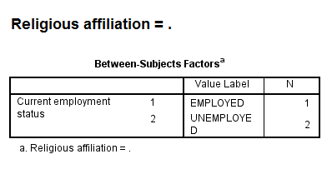

* 1. Here’s the output for the none group (the important boxes):

**Religious affiliation = NONE OR OTHER**

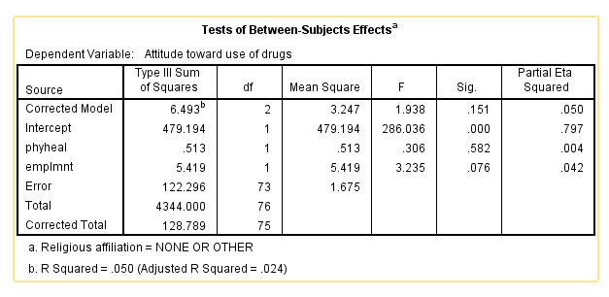

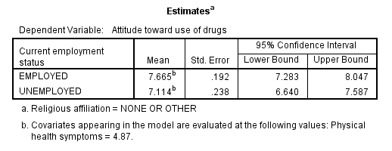

* 1. So here, I’m going to interpret the single ANCOVA output – and it’s not significantly different. So the employed and unemployed groups have the same mean (approximately 7.67 and 7.11 – yes these numbers are different, but not significantly different).
  2. You would keep going through all the ANCOVAs until you’ve done all the tests (output not shown, but summary table below).

|  |  |  |  |  |
| --- | --- | --- | --- | --- |
| Mean 1 | Mean 2 | F(df,df), p | η2 | Explain |
| None  Employed | None  Unemployed | *F*(1, 73) = 3.24, *p* = .08 | .04 | Not different |
| Catholic  Employed | Catholic  Unemployed | *F*(1,116) = 3.43, *p* = .07 | .03 | Not different |
| Protestant  Employed | Protestant  Unemployed | *F*(1,172) = 3.40, *p* = .07 | .02 | Not different |
| Jewish  Employed | Jewish  Unemployed | *F*(1,89) = .40, *p* = .53 | <.01 | Not different |

* 1. Note: So what happened? Why didn’t we get any significant post hocs if we got a significant interaction?
  2. Couple reasons:
     1. If the interaction is small, sometimes the correction factor (aka Tukey, Bonferroni), will wipe out the small differences that existed in your omnibus ANOVA.
     2. The differences in means existed in the other direction: so if I had run analyses comparing each religion for employed groups and then compared religions for unemployed groups, I would have found significant differences in:
        1. No differences for employed.
        2. Unemployed: none v catholic, none v protestant
     3. The differences in means are in a strange combination you wouldn’t test.
        1. For example, it doesn’t make a whole lot of sense to compare none_employed groups to jewish_unemployed groups.
  3. What would you do? Generally, you might reconsider the analysis you present / think about what that means for your hypothesis test (do you have enough people? Is this result practically important?).

Option 2: Use MOTE + t-value calculator.

1. Open MOTE.
   1. Go to Cohen’s d for independent t (or the alternatives).
2. Use the estimated marginal means for your analysis.
3. Use the descriptives box to get N for your analysis.



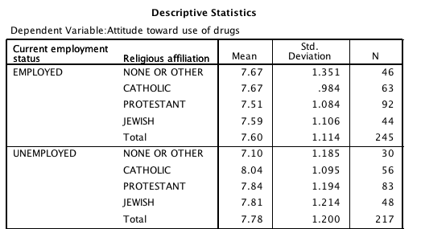

1. Enter the numbers you want to compare into MOTE.
   1. You must enter Means, SEs from the estimated marginal means box (it will auto convert SD for you), and N for each group.

|  |  |  |  |  |  |
| --- | --- | --- | --- | --- | --- |
| Mean 1 | Mean 2 | t(df) | p | d | Explain |
| None  Employed | None  Unemployed | t(74) = 2.03 | .05 | .48 | Employed have more positive attitudes. |
| Catholic  Employed | Catholic  Unemployed | t(117) = -1.71 | .09 | .31 | Not different |
| Protestant  Employed | Protestant  Unemployed | t(173) = -1.75 | .08 | .27 | Not different |
| Jewish  Employed | Jewish  Unemployed | t(90) = -0.77 | .44 | .25 | Not different |

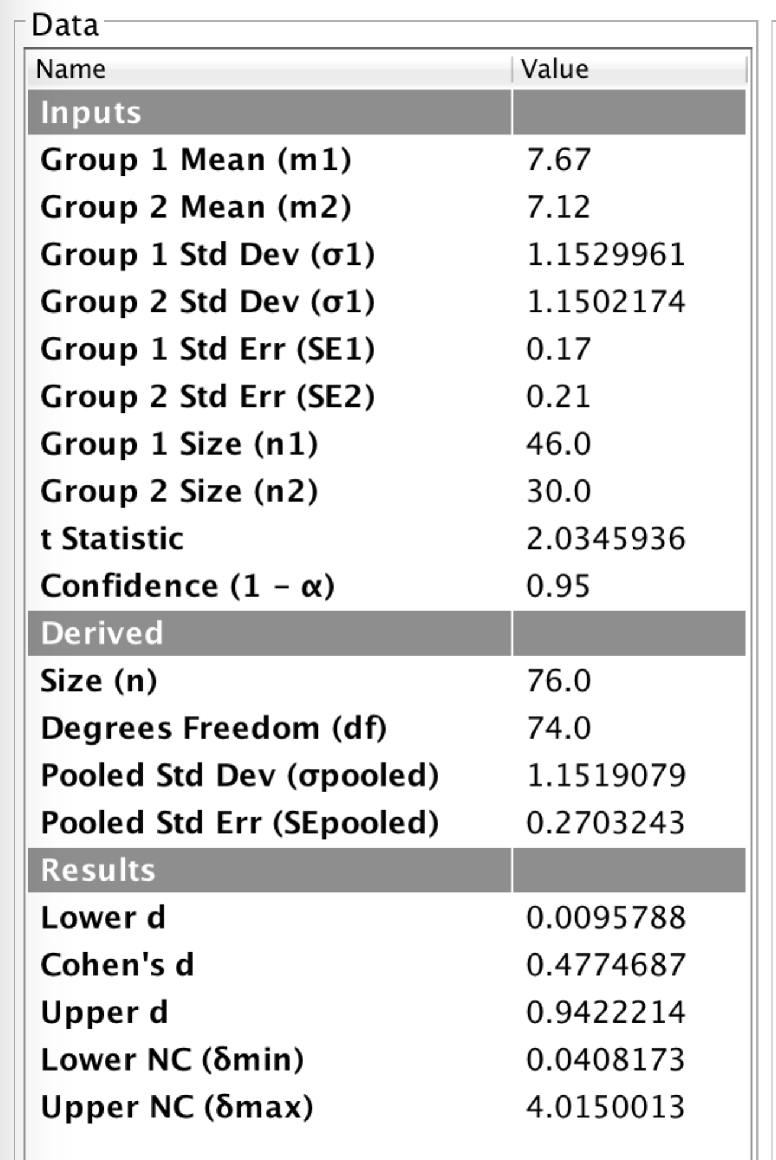

* 1. How do I get the p-value?
     1. At the moment MOTE does not list actual p (lame: working on it).
     2. You can calculate this value in excel or use: <http://vassarstats.net/tabs.html#t>
     3. Enter your t and df.
     4. Use the two-tailed p-value.

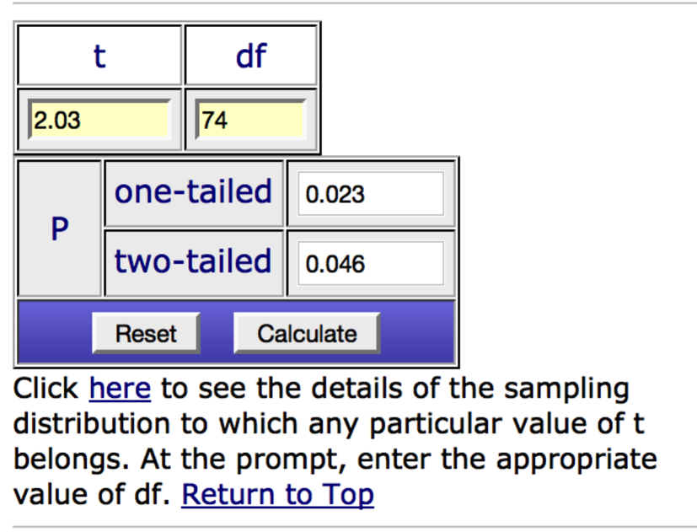

* 1. So, wait, why are these significant? And the ANCOVA way was not?
     1. You do lose power calculating using the ANCOVA procedure as your post hoc test – because you are including another variable, which your test has to account for. Therefore, the p-values will incorporate that loss of power. In some cases, it may help because for those groups the CV is a better adjustor of the means (i.e. they are more related for that specific group).

Option 3: Use an online calculator (independent t-test only).

1. Independent t-test calculator for ANCOVA marginal means: <http://www.graphpad.com/quickcalcs/ttest1.cfm>
   1. Get the adjusted conditional means.



* 1. Go to the independent t-test website (for this example).
  2. Select mean, SE, and N – we want to select SE because that is the value we have in our estimated conditional means box.

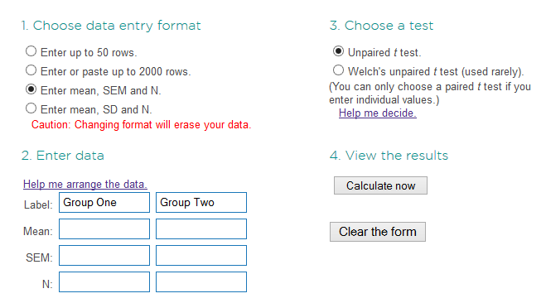

* + 1. What do I do if this website isn’t working? You can usually find a calculator for independent t to enter the means, SD/SE, and N.
    2. SD = SE * √N (TIP: remember that MOTE will give you the SD 🡪 SE transform!).
  1. N is listed in the very first descriptives box.



* 1. Finish filling in the information on the t-test website.

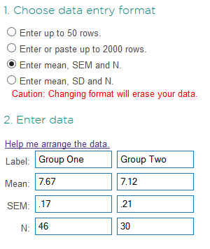

* 1. Hit calculate now.

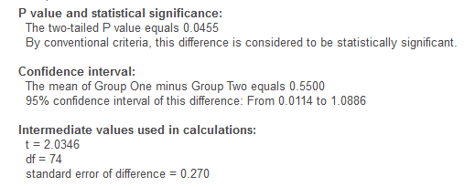

* 1. These are also the numbers you would enter into MOTE to get the effect size. Use the adjusted means and the right type of post hoc test (independent t – see above).

|  |  |  |  |  |
| --- | --- | --- | --- | --- |
| Mean 1 | Mean 2 | t(df), p | d | Explain |
| None  Employed | None  Unemployed | *t*(74) = 2.03, *p* = .05 | .48 | Not different |
| Catholic  Employed | Catholic  Unemployed | *t*(117) = -1.71, *p* = .09 | .31 | Not different |
| Protestant  Employed | Protestant  Unemployed | *t*(173) = -1.75, *p* = .08 | .27 | Not different |
| Jewish  Employed | Jewish  Unemployed | *t*(90) = -0.77, *p* = .44 | .25 | Not different |

**Charts**:

Chart builder will not do ANCOVA graphs easily. Boo ☹.

Here’s how to make the graph in word/excel:

1. Click on Charts > Column > clustered column.

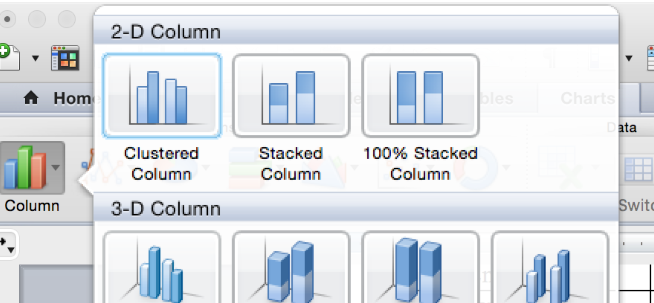

1. Excel will pop up with this information:

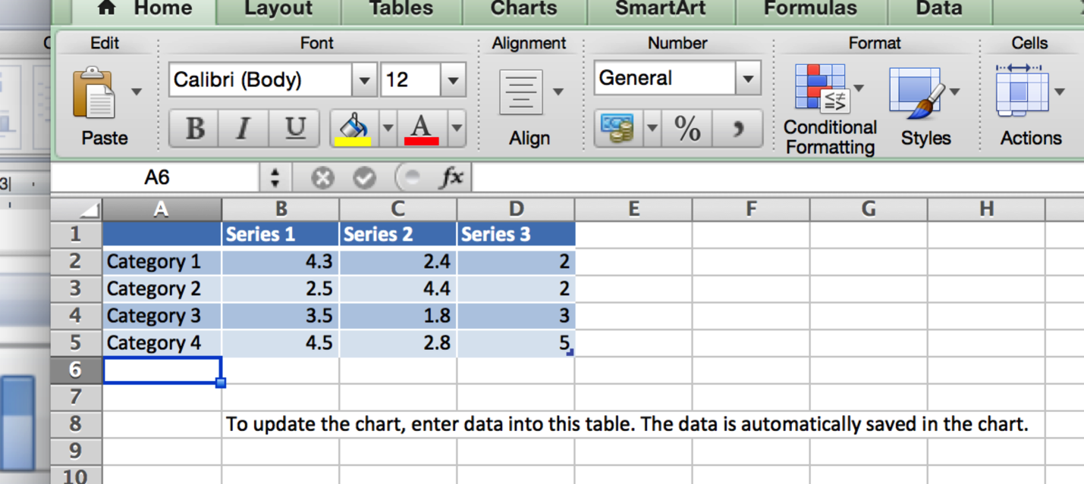

1. Fill in the appropriate information.

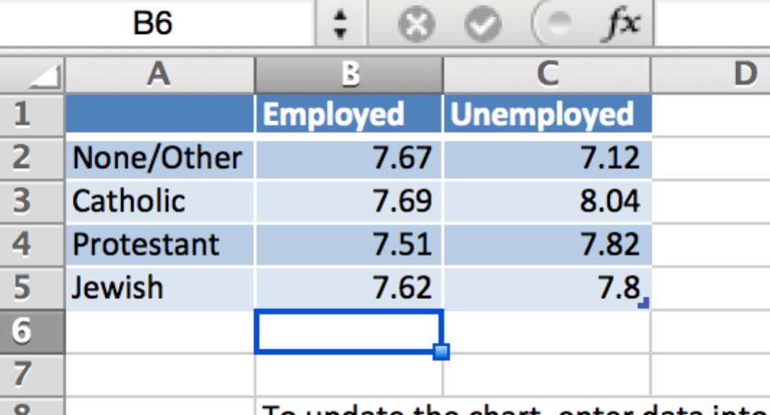

1. It will auto update the chart in word for you.
2. The tricky part is the error bars. In some space OTHER than where you have the means, enter your SEs (cause that’s what you have the easiest from the estimated mariginal means category).

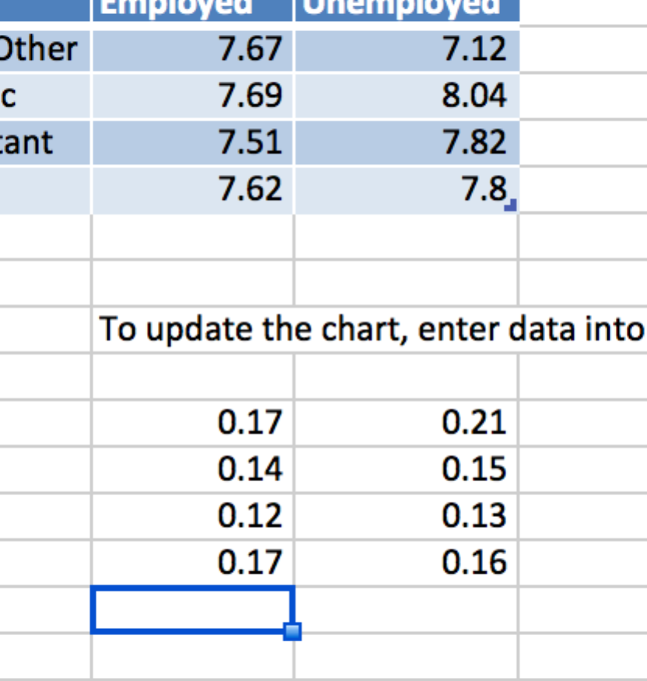

1. On your chart, double click on one of the columns.
2. Click on error bars.

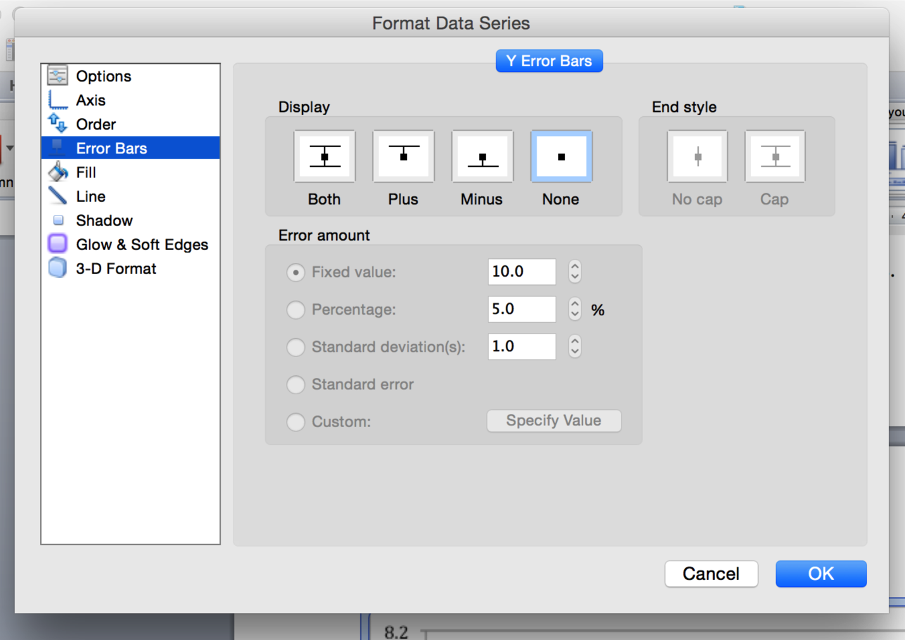

1. Click on *both* under display, and then *custom* under error amount.
2. Click specify value.

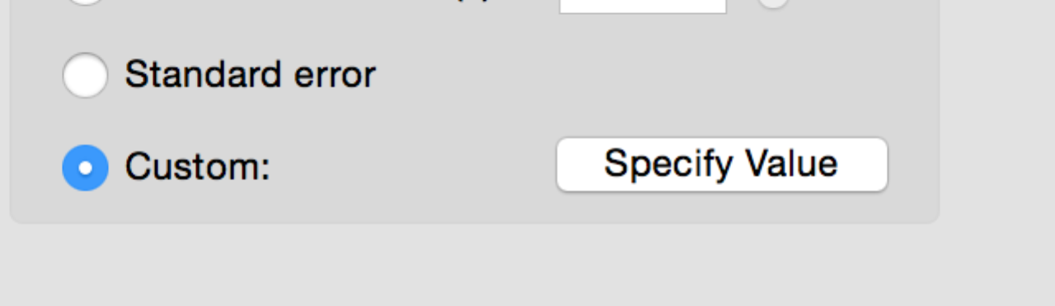

1. You will be taken to excel with the option to highlight numbers.

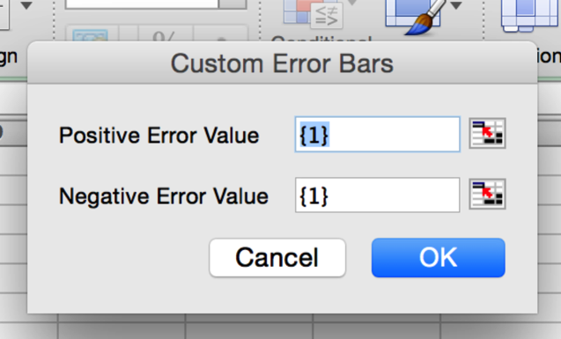

1. Highlight the numbers that you want to use. Since I highlighted the employed data first (blue columns), I want to click and drag to highlight the employed column of SEs.
2. Now you’ll see that it filled in the SE values for the positive numbers only.

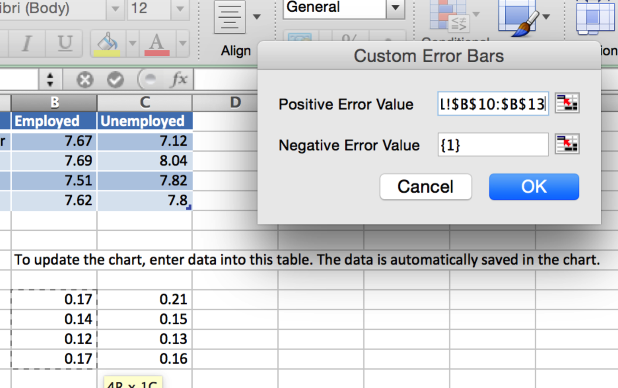

1. Click on the button to the right of the negative error value box.
2. Highlight the exact same numbers you did before.

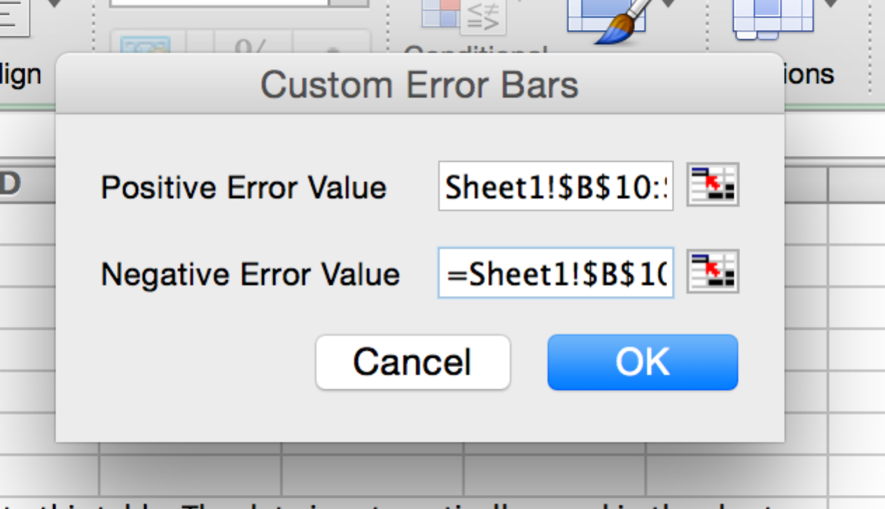

1. Hit ok, go back to word and now you should have error bars. Repeat that process for the second set of bars.
2. To get the right access labels, click on your chart, then chart layouts.

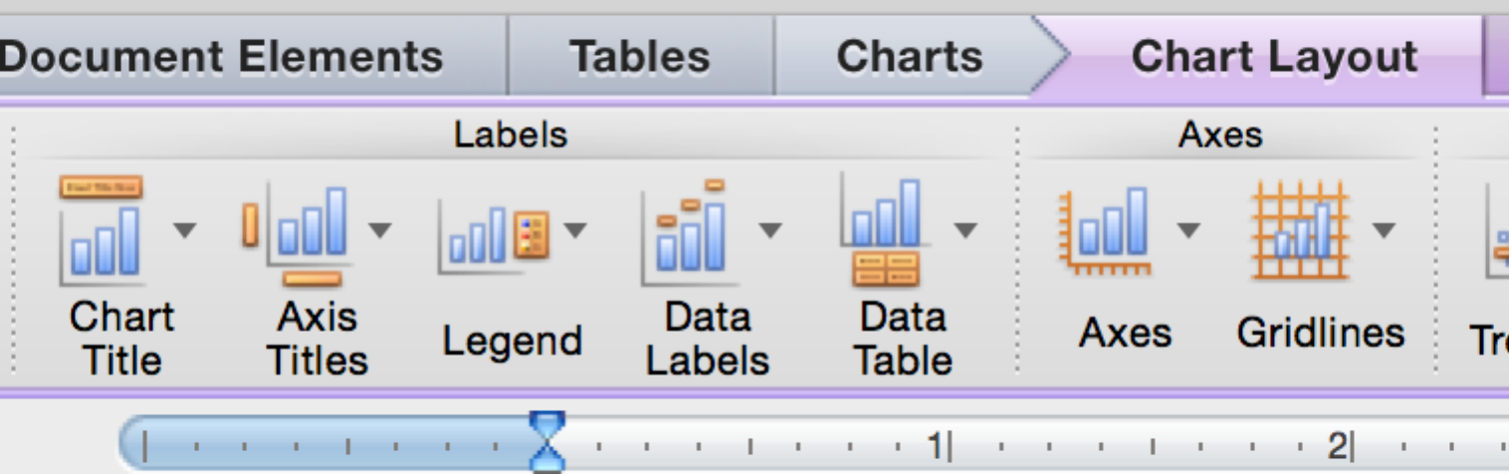

1. Click on axis titles. Click to add vertical and horizontal titles.

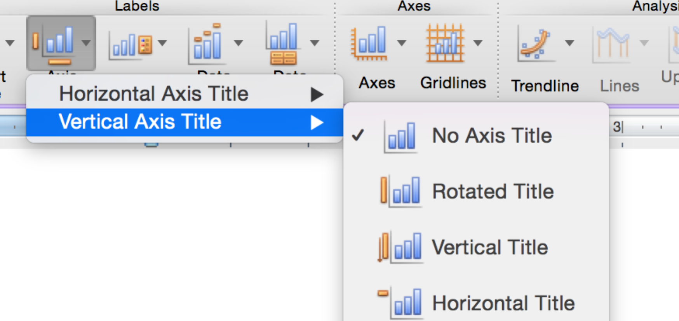

1. Click on axes, vertical axis, and axis options to edit the y-axis length.

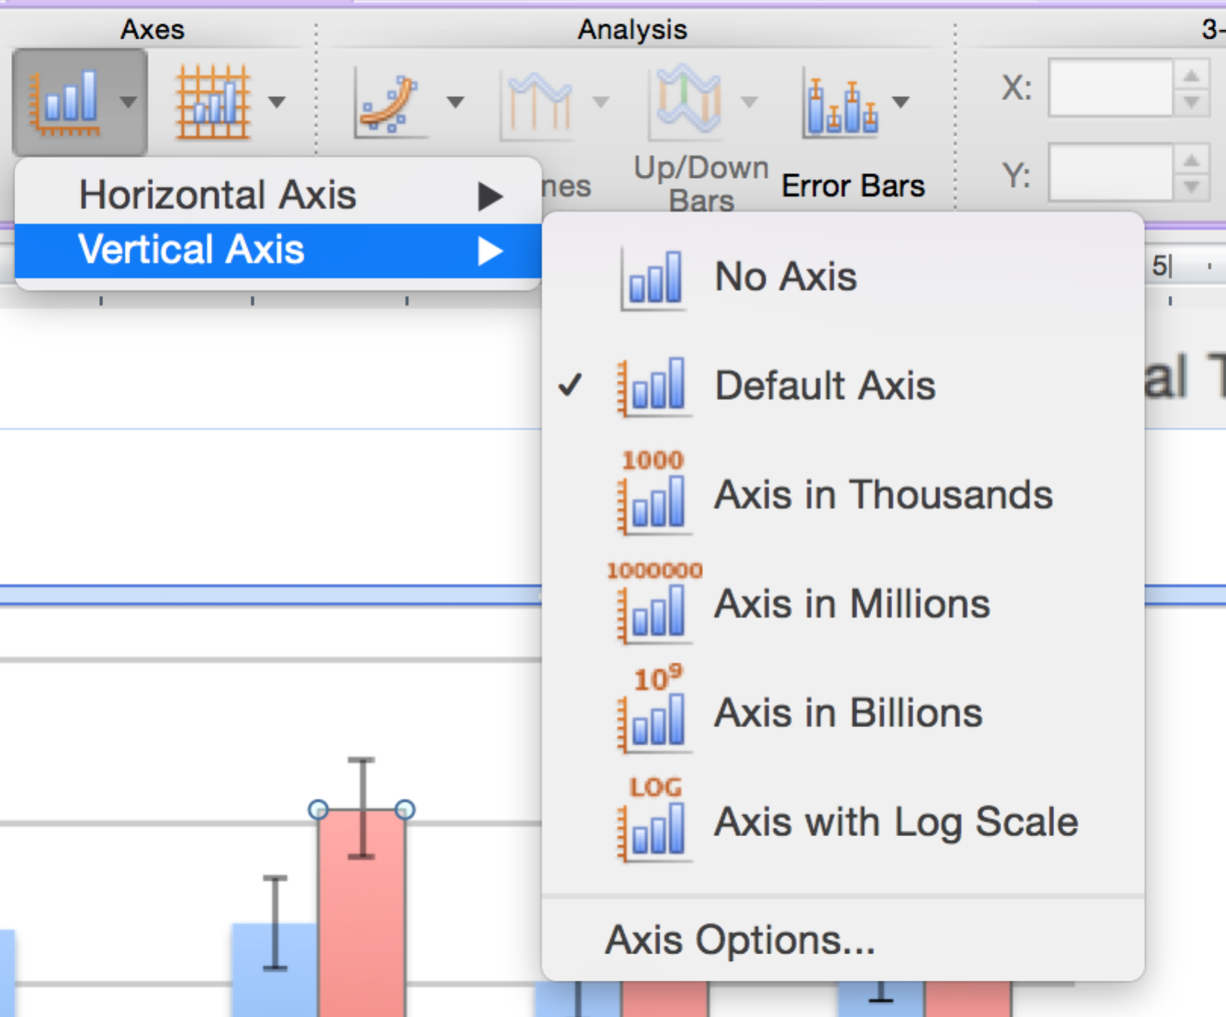

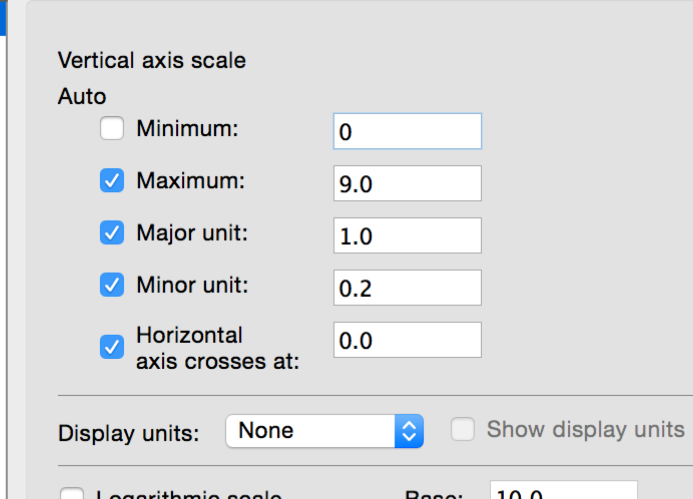

Example write up:

**Results**

Participants were measured on their attitudes toward drug use and physical health symptoms to examine the interaction between employment and religion on attitudes. The data were screened for assumptions, and while there were several univariate outliers on physical health symptoms, no multivariate outliers were present (using Mahalanobis distance). Therefore, all participants were used for this analysis. Linearity, homogeneity (Levene’s *p* = .13), homoscedasticity, and normality were all met.

A between subjects ANCOVA was used to analyze the interaction between employment and religion on attitudes towards the use of drugs after controlling for physical health symptoms. Physical health was a significant adjustor of attitudes towards the use of drugs, *F*(1, 453)=6.65, *p* = .01, *ηp2* = .01. Physical health was positively related to attitudes of the use of drugs (*r* = .13), which indicated that as more symptoms are listed more positive attitudes towards drugs exist. After controlling for physical health, the main effect of employment was not significant, *F*(1, 453) = .45, *p* = .50, *ηp2* = .001, indicating that employed participants (*M* = 7.62, *SE* = 0.08) had the same attitudes as unemployed participants (*M* = 7.70, *SE* = 0.08). The main effect of religion was marginally significant, *F*(3, 453) = 2.55, *p* = .06, *ηp2* = .02, with None or other groups reporting low attitudes (*M* = 7.40, *SE* = .13), followed by Protestant groups (*M* = 7.66, *SE* = .09), Jewish (*M* = 7.71, *SE* = .12), and finally Catholic participants (*M* = 7.86, *SE* = .11). The interaction between employment and religion was significant, *F*(3, 453) = 2.86, *p* = .04, *ηp2* = .02, which is shown in Figure 1. Independent t-tests were used to examine the adjusted means by employment type. Participants who listed none or other religions were not significantly different from Catholic participants when employed, *t*(107) = .05, *p* = .77, *d* = .01. However, participants who listed none or other religions were significantly less supportive of the use of drugs when compared to Catholic participants when unemployed, *t*(84) = 3.60, *p* < .001, *d* = .81.

# Complete Example – All Repeated

The researcher wants to know if there are differences in physical and mental health symptoms, after controlling for the use of psychotropic drugs.

*Note.* This example is a ONE-way repeated measures ANCOVA. You can use this example to apply to all versions of repeated measures. You will get more interaction terms as you add more variables in RM ANCOVA.

**IVs:**

Type of health:

Phyheal – physical health symptoms – higher scores indicate more health problems.

Menheal – mental health symptoms – higher scores indicate more mental health problems.  
**CV:**

Psydrugs – listed use of psychotropic drugs – higher numbers indicate more drugs.

**DV:**

Number of symptoms listed.

**Assumptions Checks:**

1. Accuracy:
   1. Analyze > descriptives > frequencies.
   2. Move over your IVlevels/DV and CV.
   3. Click statistics > min/max, you can also check out the means, SD, and skew/kurtosis if you want to look ahead.

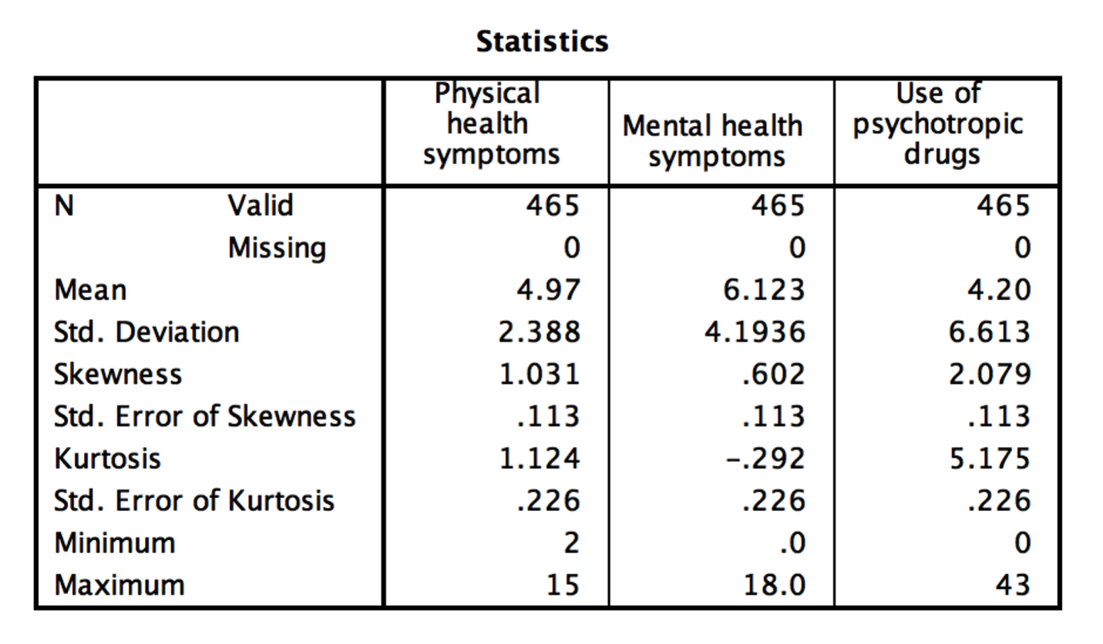

* 1. I don’t see any accuracy errors – the use of psychotropic drugs seems kind of high but if I know that’s a reasonable value, then it would be ok.

1. Missing data
   1. You check in the same way – I don’t have any missing data.
2. Outliers
   1. Multivariate – this example is repeated measures, so I’m going to check for a strange pattern of data across the DV and the CV.
   2. Create a fake variable to use for your fake regression.
      1. Transform > compute variable.



* + 1. Call the target variable “random”. Use one of the random functions to create your random variable.



* + 1. Hit “ok”, and it will create a new random variable for you.
  1. Run a fake regression. Analyze > Regression > Linear.



* 1. Move your random variable into the DV box. Put your **CV and DV** into the independent(s) box.

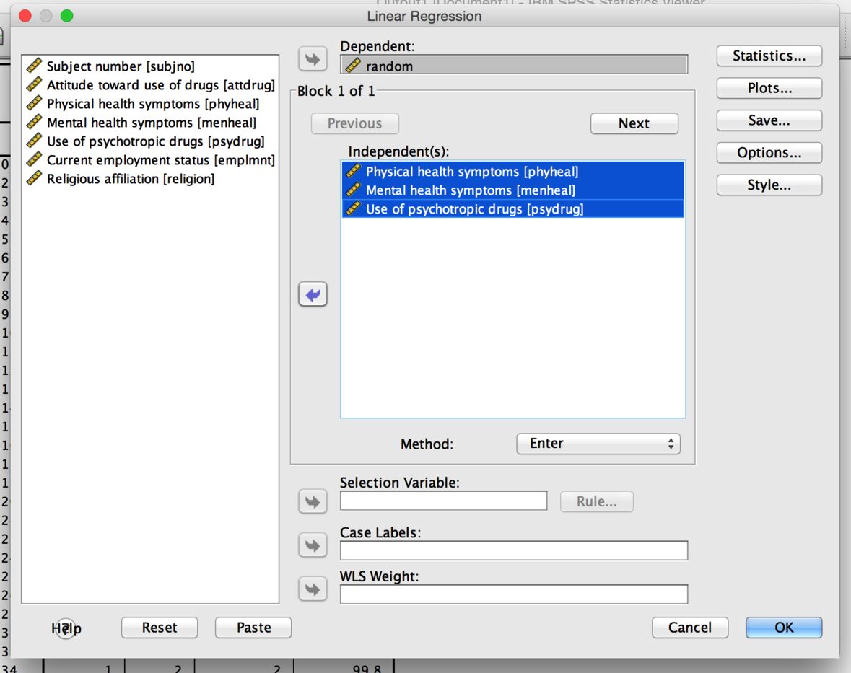

* 1. Hit Plots.



* + 1. Put zpred in Y and zresid in X. This section will create the residual plots for other assumptions checks. Check histogram and normal probability plot.
  1. Hit Save.



* + 1. Check Mahalanobis – it will create another new variable for you to check.
    2. Go back to the data set, and sort cases descending for Mahalanobis.
  1. You will need a cut off value to understand these scores.
     1. The cut off value is chi-square with degrees of freedom = number of variables, p<.001.
     2. Here we have three variables (CV and two levels DV), p<.001, chi square = 13.82 cut off score.
     3. You will look for people who have a Mahalanobis score greater than > 16.27.

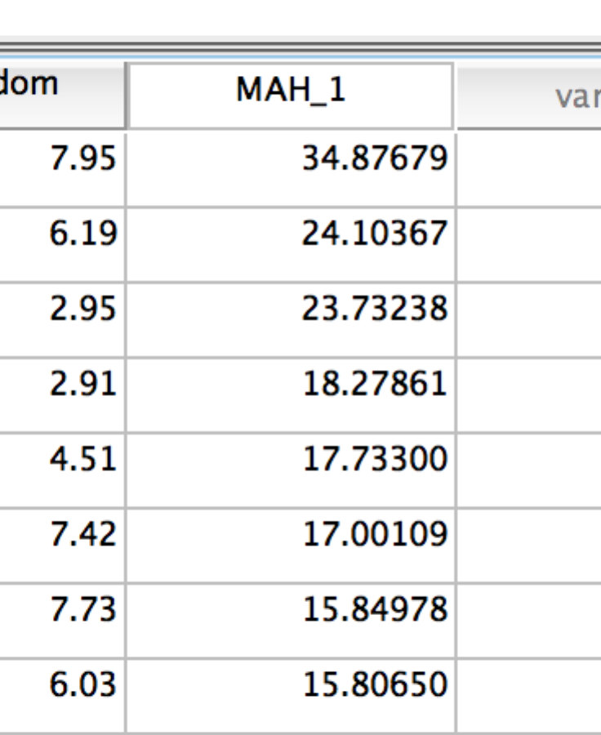

* + 1. We have six multivariate outliers. Delete’em!

1. Multicollinearity – here we want to check *two* separate things:
   1. That the CVs are not too correlated – here we only have one CV, so nothing to check (remember r > .70 becomes problematic).
   2. That the levels of the IV are not too correlated – with repeated measures, you basically just want to make sure that things are not so correlated that it won’t run (r >=.999).
   3. Don’t worry about the CV-DV correlation – you want these to be correlated! That’s the point of ANCOVA (so it’s part of hypothesis testing).

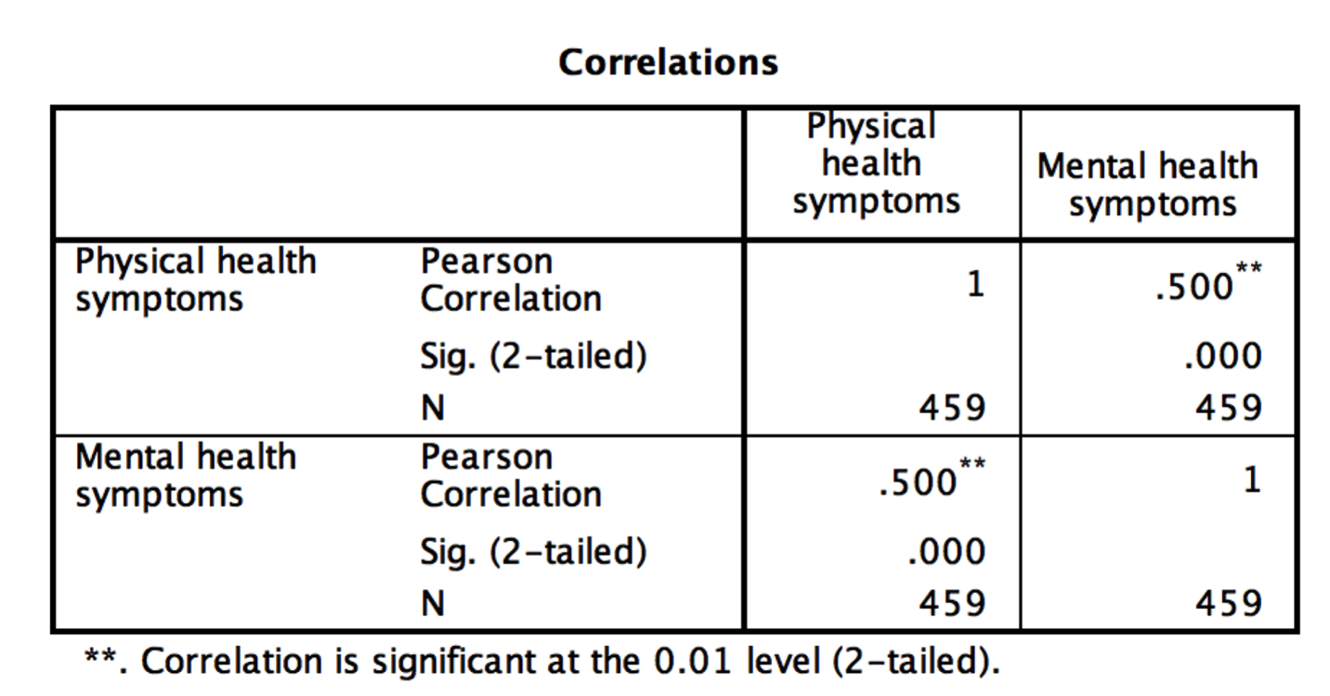

* 1. These are the levels of the IV, not too correlated so we are goo.

1. Linearity.
   1. You need both the levels of the DV and the CV to be linearly related.
   2. You can check with your multivariate graph (below – looks ok).
   3. Or you can make a set of scatter matrices and look at each pair of variables.
      1. Graphs > chart builder

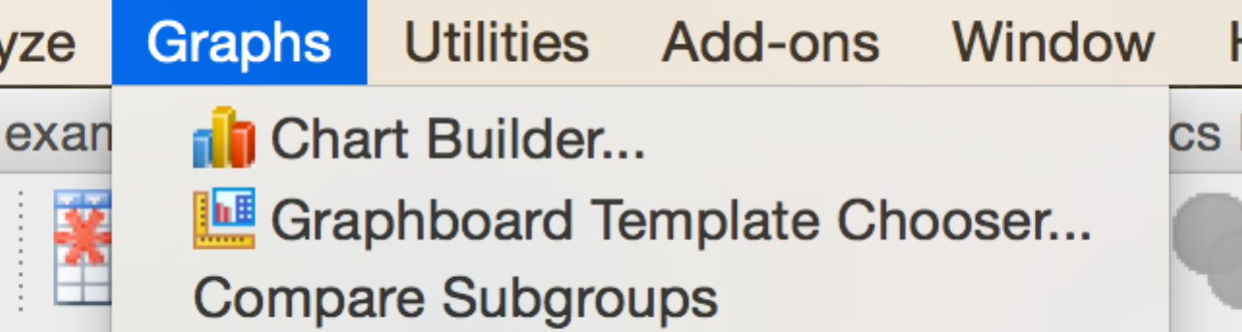

* + 1. Scatter/dot > scatterplot matrix

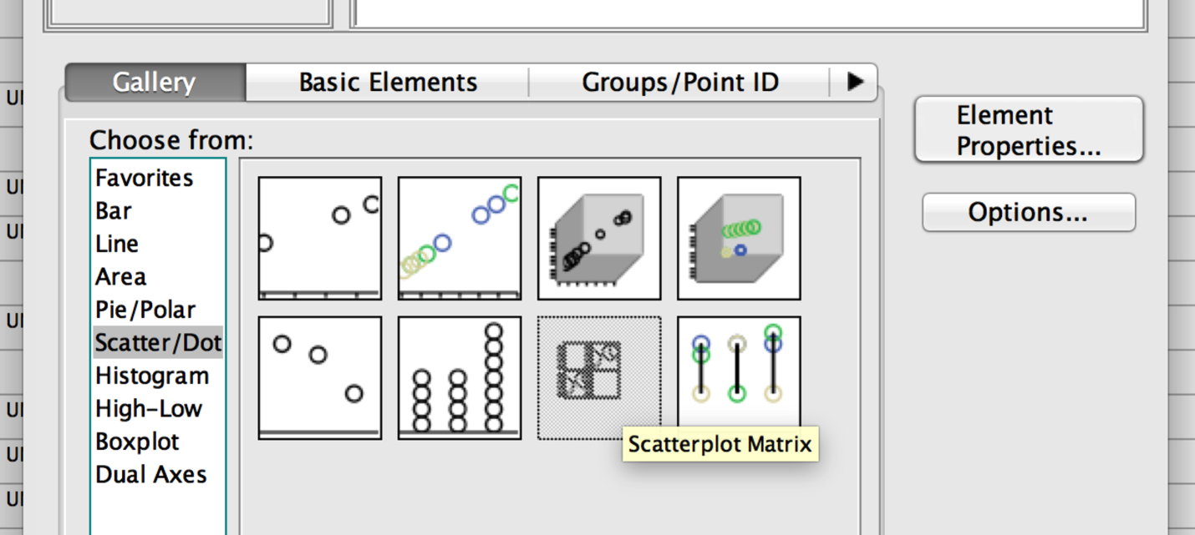

* + 1. Drag all your variables into X axis until you get the red plus symbol.

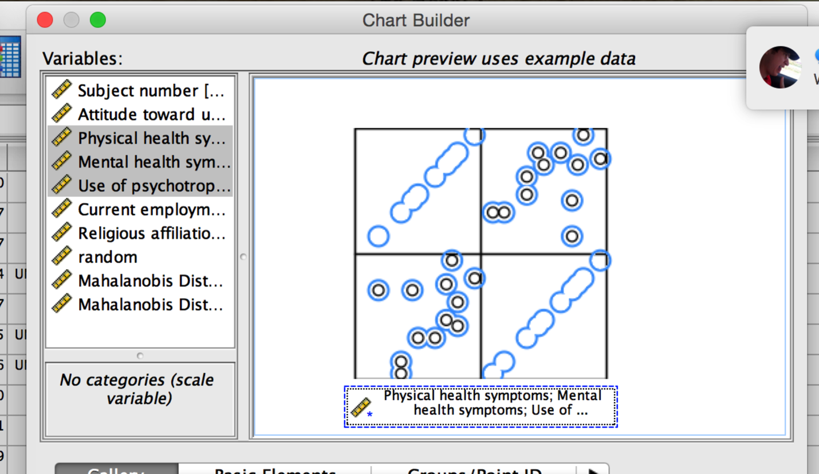

* + 1. Hit ok!
    2. None of these look curvilinear, so we are ok.

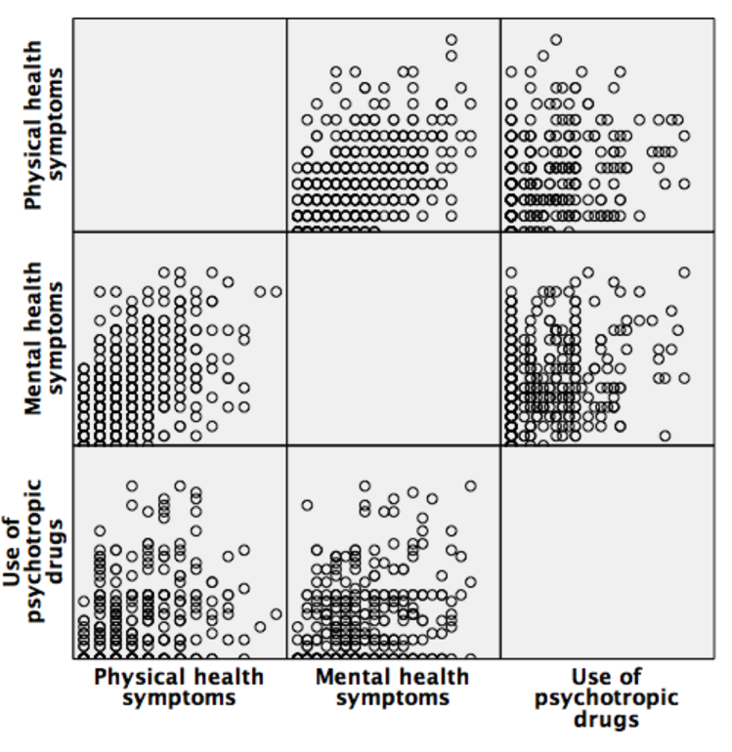

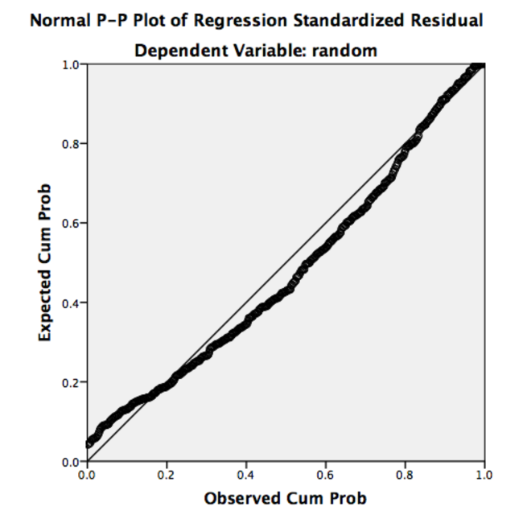

1. Normality – we want the levels of the IV and the CV to be normal.
   1. You can check with your multivariate histogram (below).
   2. If it’s not normal, we can check skew and kurtosis values from descriptives (analyze > descriptives > frequencies > statistics > skew/kurtosis). We do NOT want them to be over -3, 3.
   3. You can also look at the univariate histograms (not pictured), but here it’s clear that it’s ok (little bit of positive skew, more of a tail on the positive side), and that’s probably because of the CV because skew/kurtosis values are higher than the others (but not over the cut off score).

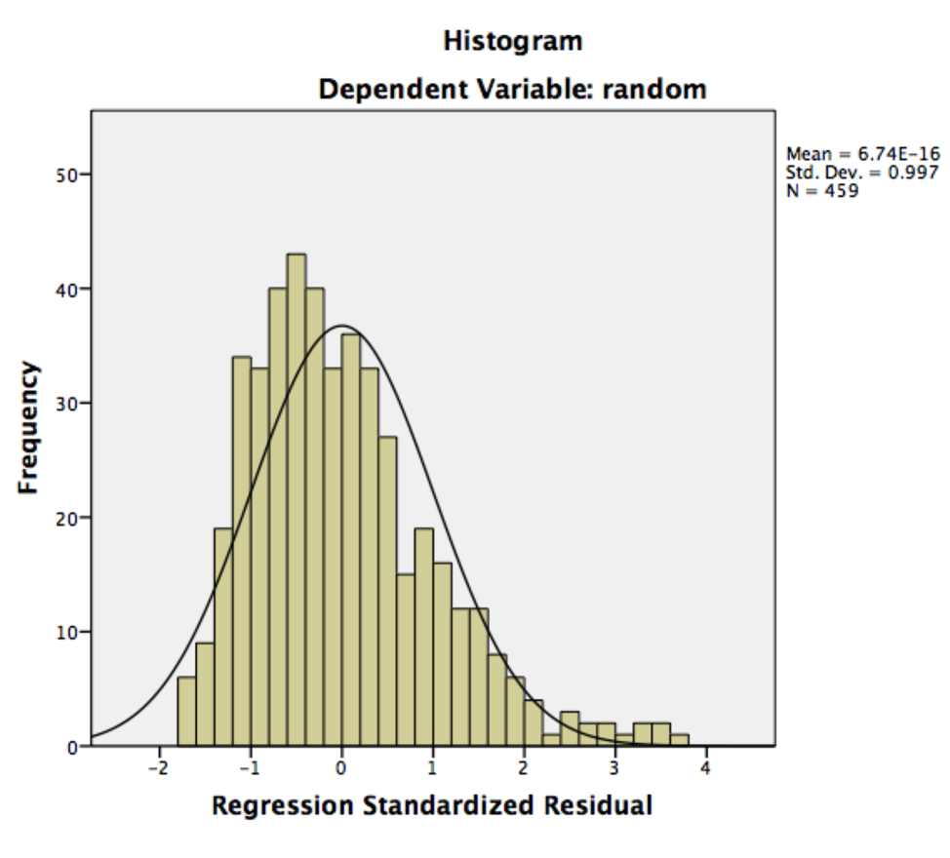

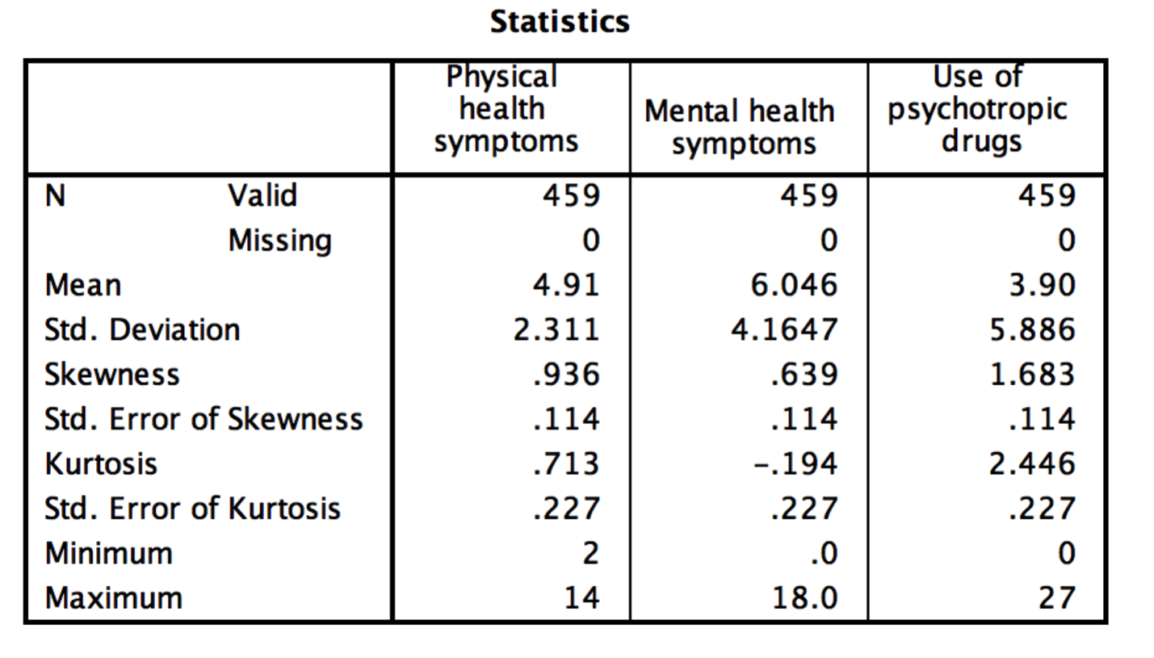

1. Homogeneity – here we are going to check the residual scatterplot.
   1. You want to look at the zero line going both across and down, make sure the spread around zero is roughly equal. We have the same problem we did before, more people on the positive side, but it should be ok.

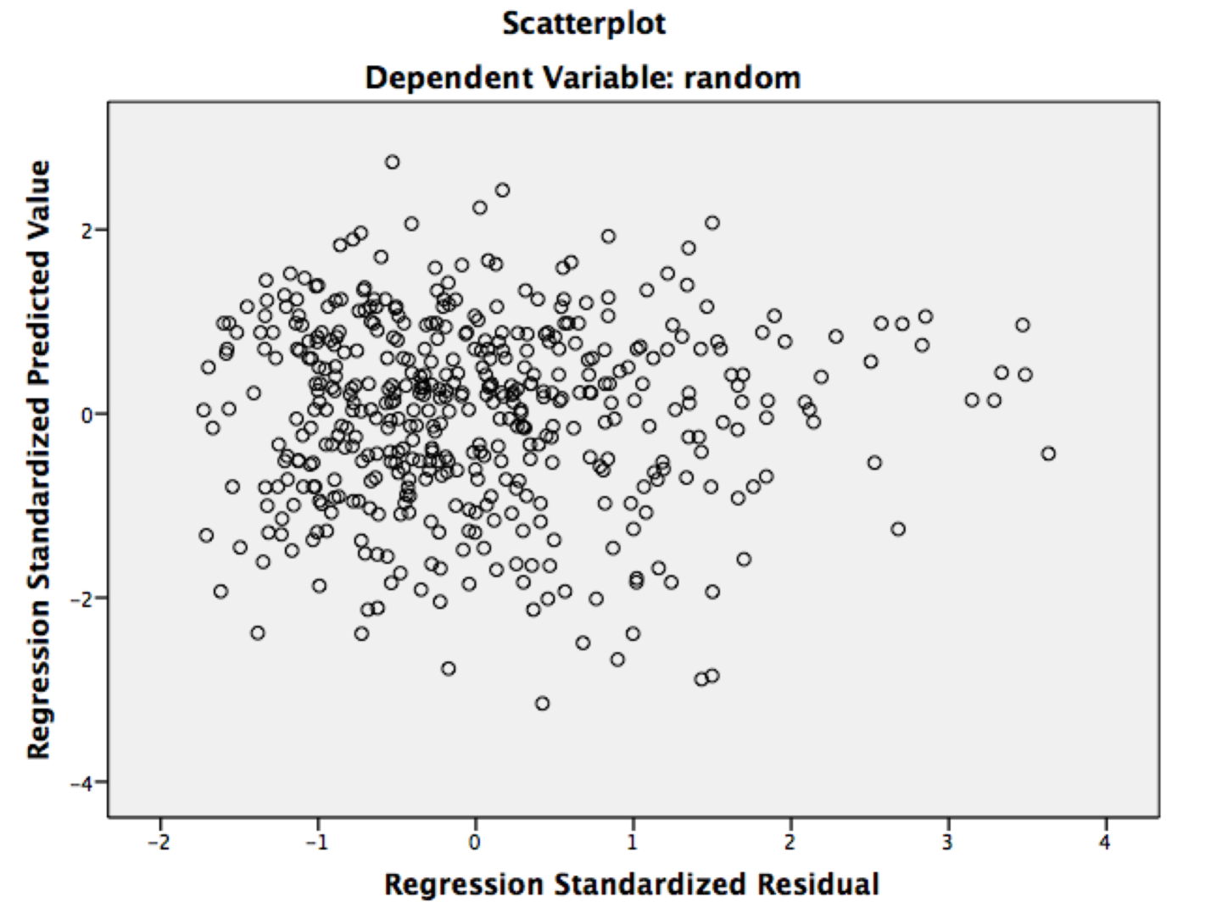

1. Homoscedasticity – since ANCOVA is partially regression, we want to check for homoscedasticity. You want to make sure that the dots are mostly blob shaped – and equal spread all the way down the zero line.
   1. This graph is pretty good.

**Running the analysis:**

1. Analyze > general linear model > repeated measures.

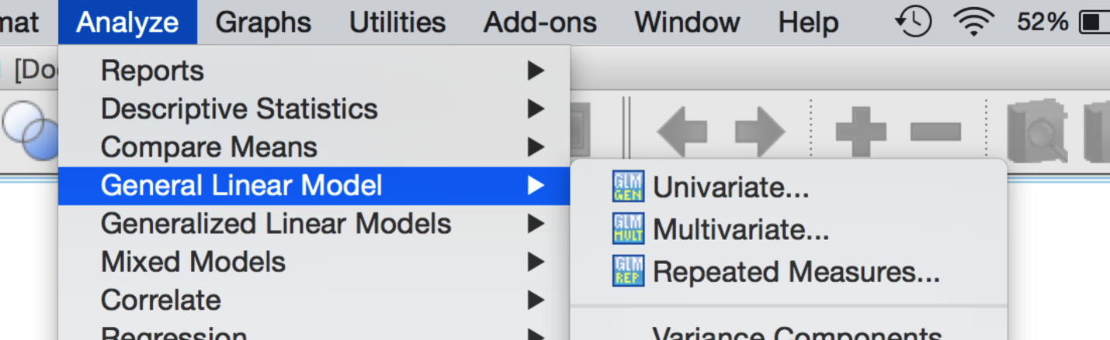

1. Enter a name for your repeated component, and enter the number of levels (i.e. list the IV name and how many columns you have).

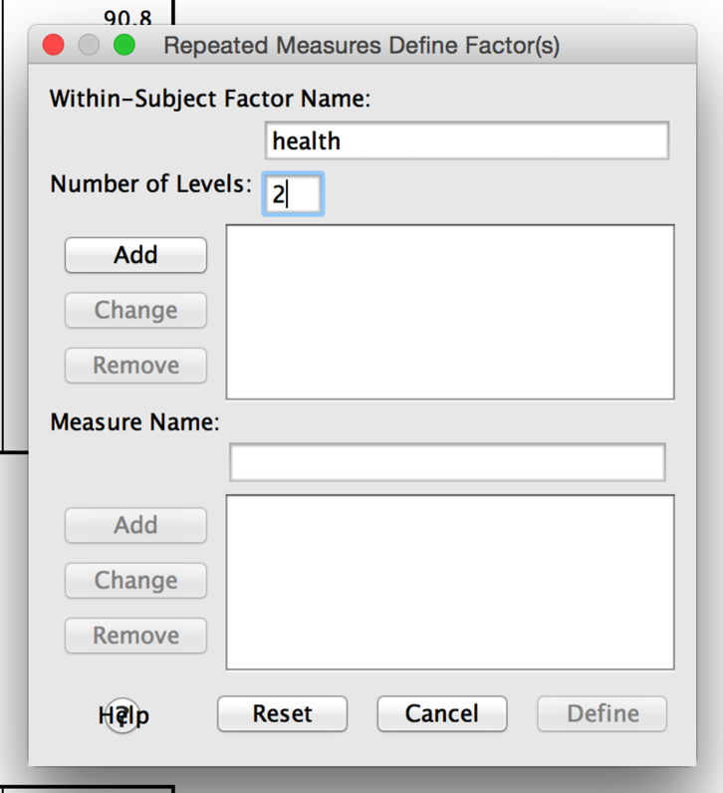

1. Move over the levels into the within-subjects variables box, put the CV(s) in the covariates box.

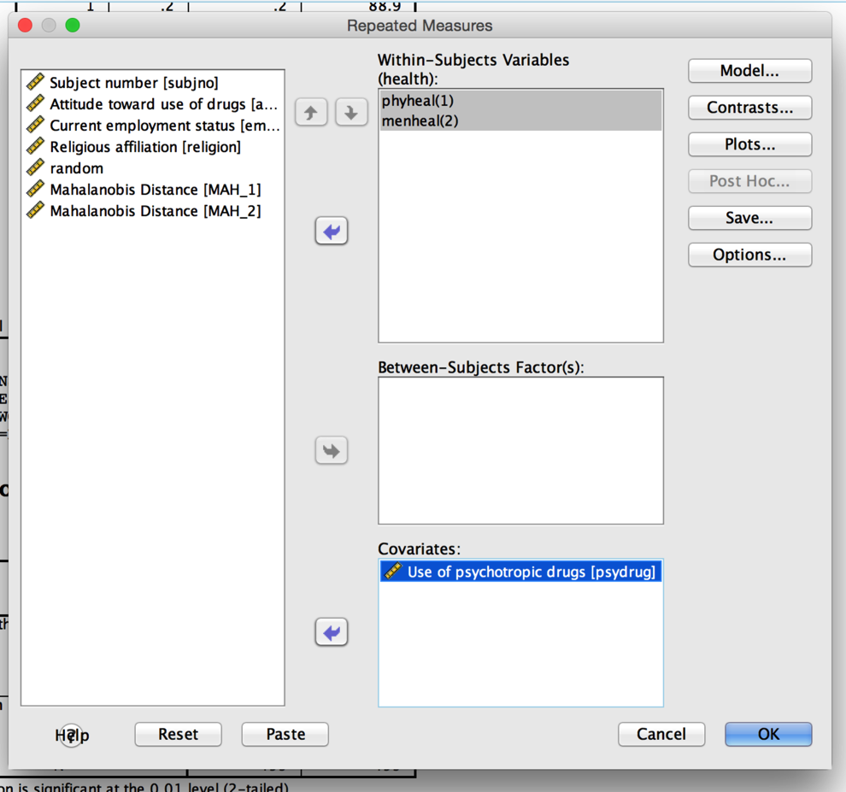

1. Click on options.
   1. Move over the variable name into “display means for” so you can get marginal means.
   2. Click descriptives, effect size for eta, and homogeneity (remember this option in all repeated will not give you any output, but that’s ok).
   3. Click compare main effects > Bonferroni.
      1. This option will give you post hocs for your main effects on the adjusted marginal means.

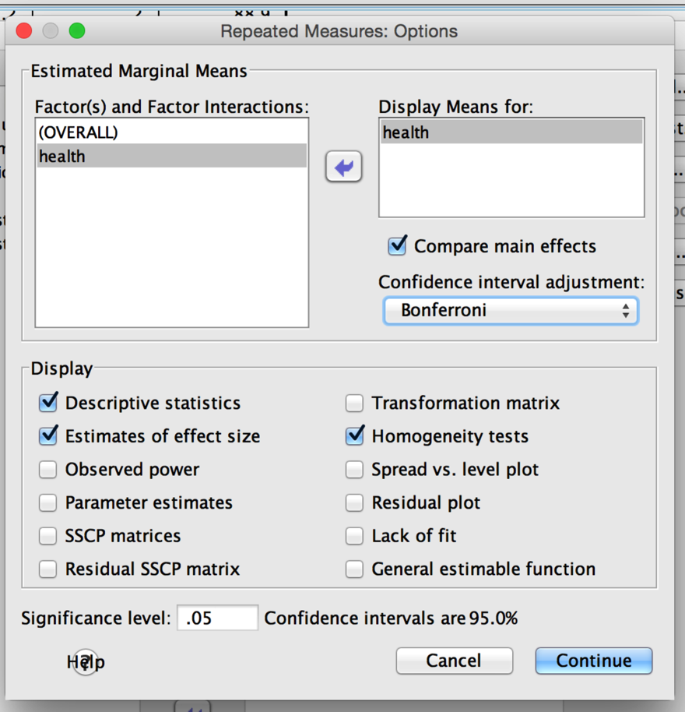

**Going from output to write up:**

1. First, check out Mauchly’s for sphericity. Here we don’t have anything to check because we only have two levels.

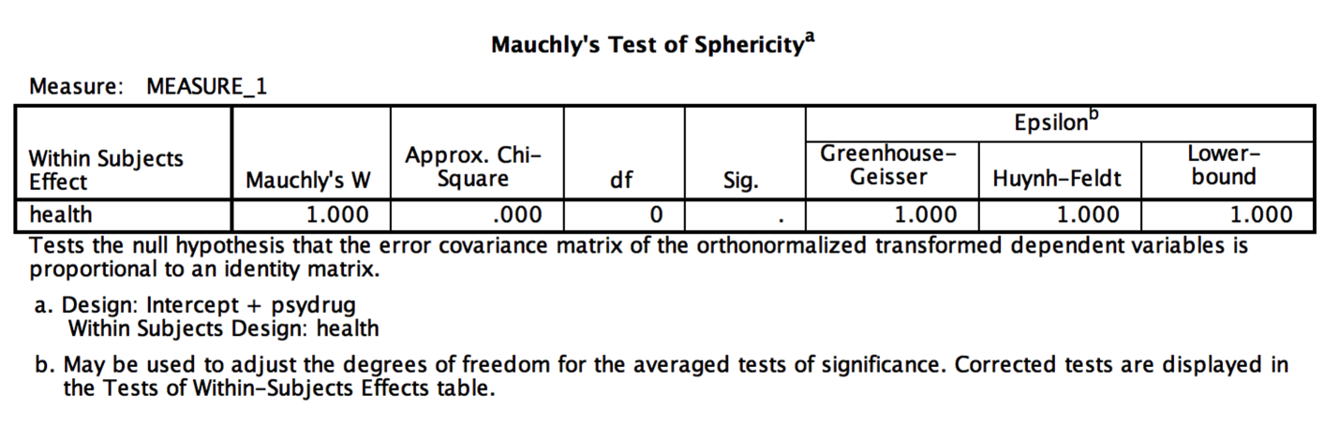

1. The within subjects box has all the F values.
   1. The main effect of health was significant, *F*(1, 457) = 16.10, *p* < .001, **η**p2 = .03.
   2. The interaction between health and psychotropic drugs was significant, *F*(1, 457) = 8.75, *p* = .003, **η**p2 = .02.

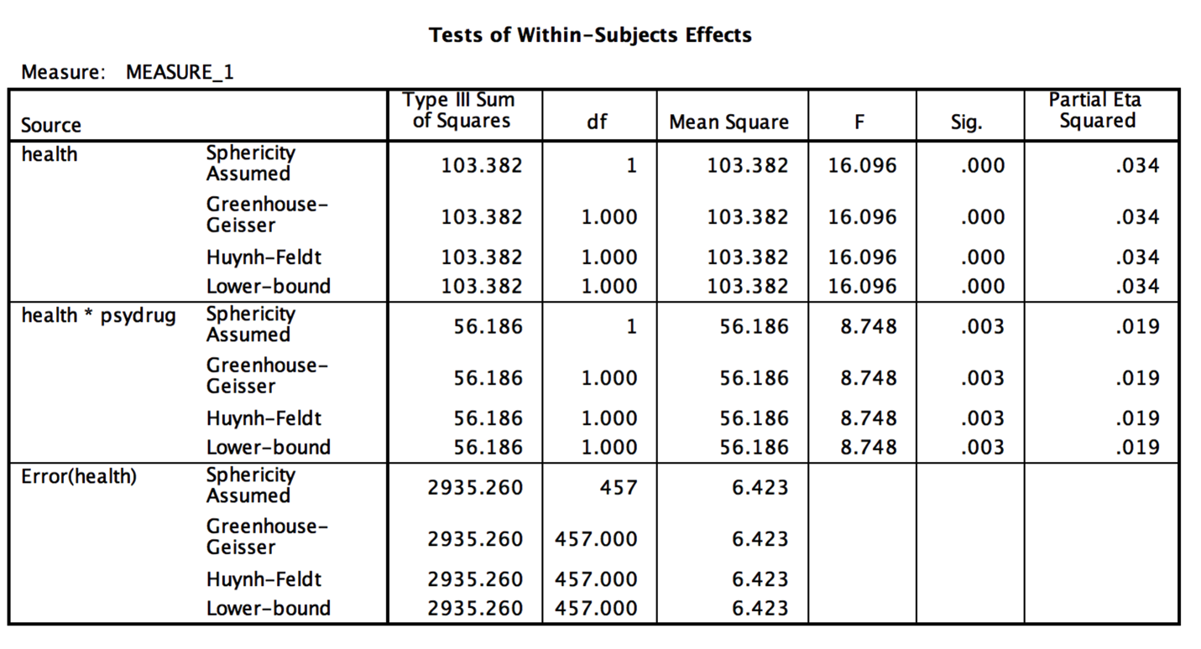

1. Notice that the omnibus test box is very similar to mixed designs – you get one error term for the main effect and interaction.
   1. Another interesting fact is that you got an interaction between the CV and the IV…but in between subjects you did not get any of that output. You can manually add that into between subjects ANCOVA – it is automatic in repeated measures, but not between subjects **¯\_(ツ)_/¯.**
2. In between subjects, we did get at least the main effect of the CV – is this covariate a significant adjustor of the DV?
   1. That’s found in the between subjects box, and it is significant, *F*(1, 457) = 72.99, *p* < .001, **η**p2 = .14.

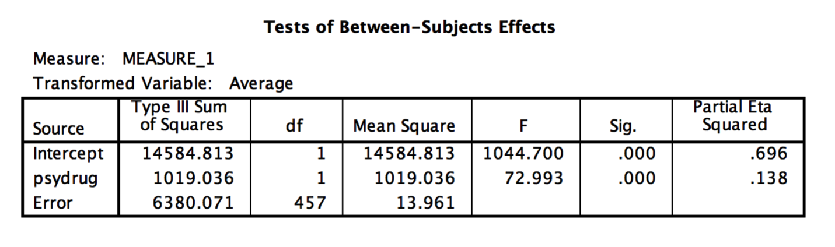

1. How do I interpret all this information?
   1. Main effect of the IV: health.
      1. Check out the adjusted marginal means box, and if necessary (aka 3+ levels), the Bonferroni post hoc box (not included because we only have two levels).
      2. People seem to have more mental health symptoms than physical health symptoms (can’t remember 1 and 2? Go back to the top of your output and look at the within subjects factors box).

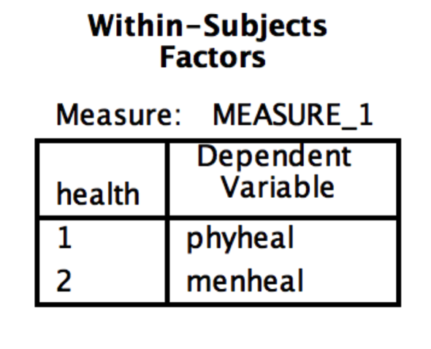

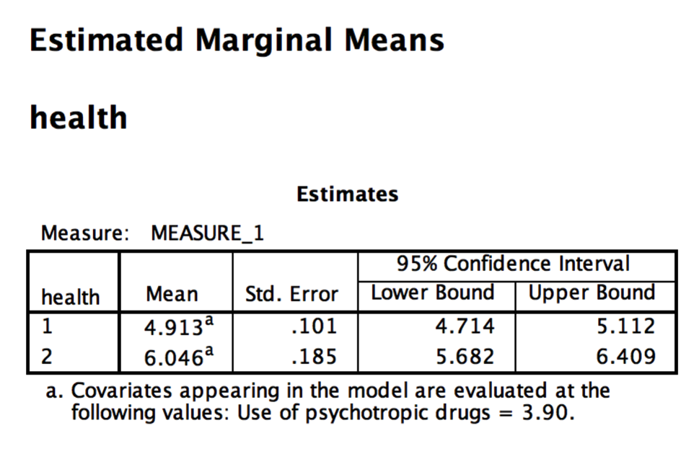

* 1. Main effect of the CV:
     1. Your CV is an adjustor of the DV – that means it’s significantly correlated (related) to the DV…but in this case we have the DV separated out into several levels. You are adjusting the ratings of symptoms, so it’s saying that over all the different levels of symptoms, this CV has a significant relationship with them. It is sort of hard to get that kind of correlation – since you have them in separate columns, but you can, take the square root of **η**p2 = .14, but label it as *r* = .37.
     2. Taking that square root is the same thing as averaging the level columns together and correlating the average IV levels with the CV.
  2. Interaction with the CV and IV:
     1. I think you get this interaction term automatically because of that exact problem listed above … an overall adjustment makes sense in theory but in practice it’s hard to do.
     2. With a significant interaction, basically you are saying that you are adjusting the levels of the IV differently. The easiest way to think about it is that there are different relationships/correlations between the IV levels and the CV.
     3. To figure out that relationship, run a correlation table between the CV and DV.
     4. For physical health, *r* = .349, *p* < .001.
     5. For mental health, *r* = .313, *p* < .001.
     6. That’s a pretty small difference, but that’s how you might explain the interaction.

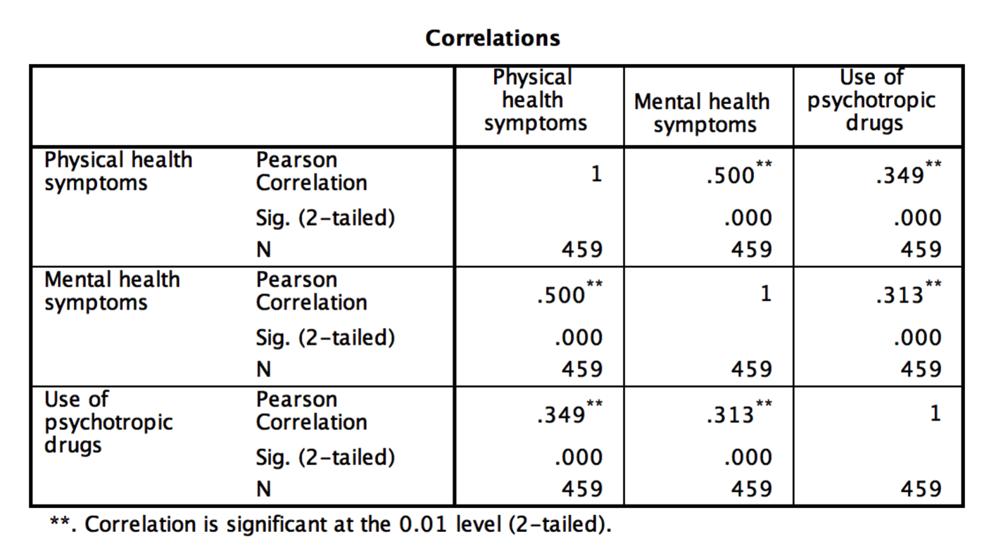

Running a post hoc:

Option 1: Use SPSS pairwise ANCOVA.

Let’s say that you had two IVs and a CV with repeated measures only. The analyses of the interaction for double repeated measures post hocs appears to be mildly uncharted territory, so here’s the best option I can think of.

For this option, we are going to use ANCOVA but limit our comparisons to two-conditions at the same time. Remember that with pairwise comparisons (aka two at a time) ANOVA = dependent t. We cannot use regular dependent t-tests run through SPSS because want to use the adjusted means and control for the CV(s). This analysis will allow us to control for the CV(s), and compare pairwise without leaving SPSS.

Here’s how all those analyses would break down:

1. Main effects of IV:
   1. Use the Bonferroni output provided by clicking compare main effects in the options window.
2. Main effects of the CV:
   1. Just interpret the effect size provided in the ANOVA box (i.e. look at **η**p2) – same thing as the correlation between the average across all conditions and the CV.
3. Interaction of the IVs:
   1. Analyze > general linear model > repeated measures.
   2. Give the test a name (maybe post hoc 1 or something).
   3. List the levels as 2.
   4. Enter your two conditions you want to compare into the 1, and 2 slots.
   5. Put your CV(s) into the covariates box.
   6. Options > move over the variable name into means. Click descriptives, effect size.
   7. Report each pairwise ANCOVA with F values, p, **η**p2, and interpret the adjusted means (similar to how we just ran the repeated measures example, and how I reported the tests described in the between subjects).
4. Interaction of one IV and the CV:
   1. Just interpret the effect size provided in the ANOVA box (i.e. look at **η**p2) – same thing as the correlation between the average across those levels and the CV.
5. Interaction of the two IVs and the CV (ugh):
   1. Run a bivariate correlation between the CV and the conditions (all the different columns) to talk about the CV/condition means interactions. Report those correlations.
   2. Then run the interaction of the IVs to understand that condition mean differences part of the three way interaction.
   3. (also consider learning mixed linear modeling and moderation analyses – see regression chapter).